**AI-Powered Sustainable Agriculture**

A MAJOR PROJECT REPORT

*Submitted by*

**Jayesh Poonia [RA2111030010261]**

**Vedika Singh [RA2111030010295]**

*Under the Guidance of*

***Dr. D SAISANTHIYA***

(Assistant Professor, Department of Networking and Communications)

*in partial fulfillment of the requirements for the degree*

*of*

**BACHELOR OF TECHNOLOGY**

**in**

**COMPUTER SCIENCE ENGINEERING**

**with specialization in CYBER SECURITY**



**DEPARTMENT OF NETWORKING AND COMMUNICATIONS COLLEGE OF ENGINEERING AND TECHNOLOGY**

**SRM INSTITUTE OF SCIENCE AND TECHNOLOGY**

**KATTANKULATHUR- 603 203**

**MAY 2025**

Department of Computational Intelligence

**SRM Institute of Science & Technology**

**Own Work* Declaration Form**

**Degree/ Course: B Tech- Computer Science and Engineering in Cyber Security**

**Student Name: Jayesh Poonia, Vedika Singh**

**Registration Number: RA2111030010261, RA2111030010295**

**Title of Work :** **AI-Powered Sustainable Agriculture**

I / We hereby certify that this assessment compiles with the University’s Rules and Regulations relating to Academic misconduct and plagiarism**, as listed in the University Website, Regulations, and the Education Committee guidelines.

I / We confirm that all the work contained in this assessment is my / our own except where indicated, and that I / We have met the following conditions:

* Clearly referenced / listed all sources as appropriate
* Referenced and put in inverted commas all quoted text (from books, web, etc)
* Given the sources of all pictures, data etc. that are not my own
* Not made any use of the report(s) or essay(s) of any other student(s) either past or present
* Acknowledged in appropriate places any help that I have received from others (e.g. fellow students, technicians, statisticians, external sources)
* Compiled with any other plagiarism criteria specified in the Course handbook / University website

I understand that any false claim for this work will be penalized in accordance with the University policies and regulations.

|  |
| --- |
| **DECLARATION:** |
| I am aware of and understand the University’s policy on Academic misconduct and plagiarism and I certify that this assessment is my / our own work, except where indicated by referring, and that I have followed the good academic practices noted above.  Jayesh Poonia - RA2111030010261  Vedika Singh - RA2111030010295 |
| If you are working in a group, please write your registration numbers and sign with the date for every student in your group.  Jayesh Poonia -RA2111030010261  Vedika Singh -RA2111030010295 |



SRM INSTITUTE OF SCIENCE AND TECHNOLOGY KATTANKULATHUR – 603 203

BONAFIDE CERTIFICATE

Certified that **18CSP109L-Major Project** report titled “**AI-Powered Sustainable Agriculture**” is the Bonafide work of “**Jayesh Poonia [RA2111030010261], Vedika Singh [RA2111030010295]**” who carried out the project work under my supervision. Certified further, that to the best of my knowledge the work reported herein does not form any other project report or dissertation on the basis of which a degree or award was conferred on an earlier occasion on this or any other candidate.

|  |  |
| --- | --- |
| **SIGNATURE**  **Dr. Saisanthiya D**  **SUPERVISOR**  **ASSISTANT PROFESSOR**  DEPARTMENT OF NETWORKING AND COMMUNICATIONS  **INTERNAL EXAMINER** | **SIGNATURE**  **Dr. Lakshmi M**  **PROFESSOR & HEAD**  DEPARTMENT OF NETWORKING AND COMMUNICATIONS  **EXTERNAL EXAMINER** |

**ACKNOWLEDGEMENTS**

We express our humble gratitude to **Dr. C. Muthamizhchelvan**, Vice-Chancellor, SRM Institute of Science and Technology, for the facilities extended for the project work and his continued support.

We extend our sincere thanks to **Dr. Leenus Jesu Martin M,** Dean-CET, SRM Institute of Science and Technology, for his invaluable support.

We wish to thank **Dr. Revathi Venkataraman**, Professor and Chairperson, School of Computing, SRM Institute of Science and Technology, for her support throughout the project work.

We encompass our sincere thanks to, **Dr. M. Pushpalatha**, Professor and Associate Chairperson - CS, School of Computing and **Dr. C Lakshmi,** Professor and Associate Chairperson -AI, School of Computing, SRM Institute of Science and Technology, for their invaluable support.

We are incredibly grateful to our Head of the Department, **Dr. Lakshmi M,** Professor, Department of Networking and Communications, SRM Institute of Science and Technology, for her suggestions and encouragement at all the stages of the project work.

We want to convey our thanks to our Project Coordinators **Dr. G Suseela, Dr Mary, Panel Head Subaja Chritra**, and Panel Members **Dr. Gautaman P, Dr. Preethiya T., Dr D. Saisanthiya** Department of Networking and communications, SRM Institute of Science and Technology, for their inputs during the project reviews and support.

We register our immeasurable thanks to our Faculty Advisor, **Dr. K Meenakshi**, Assistant

Professor, Department of Networking and Communications, SRM Institute of Science and Technology, for leading and helping us to complete our course.

Our inexpressible respect and thanks to our guide, **Dr. Saisanthiya D**, Assistant Professor,

Department of Networking and Communications, SRM Institute of Science and Technology, for

providing us with an opportunity to pursue our project under his mentorship. He provided us with the freedom and support to explore the research topics of our interest. His passion for solving problems and making a difference in the world has always been inspiring.

We sincerely thank all the staff members of Department of Networking and Communications, School of Computing, S.R.M Institute of Science and Technology, for their help during our project. Finally, we would like to thank our parents, family members, and friends for their unconditional love, constant support and encouragement

Authors

**Jayesh Poonia [RA2111030010261]**

**Vedika Singh [RA2111030010295]**

**ABSTRACT**

Agriculture is one of the largest and most critical sectors, providing food security and economic stability worldwide. However, it faces multiple challenges, including climate fluctuations, inefficient resource management, soil degradation, and plant diseases, all of which negatively impact crop productivity and sustainability. Traditional farming practices rely on experience-based decision-making, often failing to consider real-time environmental changes, weather conditions, and technological advancements. Farmers often lack access to data-driven final conclusions, leading to bad crop selection and have the improper fertilizer application or it get wasted by washed down by rain or water, and be insufficient to delay the disease. To address these critical issues, we propose an AI-driven Smart Agriculture System that leverages ML, DL, and NLP to enhance decision-making and increase agricultural efficiency.

Our system incorporates Random Forest (RF) models for crop and fertilizer recommendations, analysing soil properties, climate variations, historical agricultural data, and weather conditions to provide farmers with optimal strategies for cultivation. Furthermore, plant image-based disease detection is performed using ResNet9 that is based on deep learning model that ensuring early result and it identifies the disease of plant accurately, which in turn is crucial to prevent yield losses and minimizing the overuse of pesticides. The system integrates real-time weather APIs to adjust recommendations based on ongoing climate fluctuations, making farming decisions more adaptive and data-driven. A significant innovation in our system is the inclusion of an NLP-powered multilingual chatbot, which allows farmers to interact through text or speech in multiple languages, enhancing accessibility for rural and illiterate farmers. This chatbot connects with AI-driven models and external data sources to provide personalized, real-time recommendations on crop selection, fertilizer use, pest control, and weather conditions. The AI-powered Decision Support System (DSS) fosters precision farming, sustainability, and optimized resource utilization, closing the gap in traditional farming methods and significantly reducing the pit that is between modern technology. By providing scalable, adaptable, and real-time agricultural insights, this system aims to revolutionize global farming practices, making smart agriculture accessible to farmers of all scales, especially in resource-constrained regions.

|  |  |
| --- | --- |
| **ABSTRACT** | **v** |
| **TABLE OF CONTENTS** | **vi** |
| **LIST OF FIGURES** | **vii** |
| **LIST OF TABLES** | **viii** |
| **ABBREVIATIONS** | **Ix** |
| **CHAPTER NO. TITLE** | **Page No.** |
| 1. **INTRODUCTION**    1. Overview    2. Problem Statement    3. Motivation    4. Sustainable Development Goal of the Project    5. Objective of project    6. Project Domain    7. Scope 2. **LITERATURE SURVEY**    1. Limitations    2. Research Objectives    3. Traditional agriculture practices and challenges    4. Research Gaps    5. Importance of XAI in Agriculture    6. ML application in agriculture    7. Summary 3. **SYSTEM AGRICULTURE AND DESIGN**    1. Introduction    2. System overview    3. Proposed Architecture    4. Data Processing and Feature Engineering    5. Modelling layer    6. Explainability Layer    7. Visualization And Reporting Layer    8. Summary 4. **METHODOLOGY**    1. Modules    2. DATA ACQUISITION AND PREPARATION    3. Feature Engineering    4. Model Development and Training    5. Evaluation and Validation 5. **RESULTS AND DISCUSSION**    1. Results    2. Model Performance Comparison    3. User Feedback and usability study 6. **CONCLUSION AND FUTURE WORK**    1. Advanced crop yield prediction models    2. Future enhancement of chatbot model    3. Integration of IOT and real time monitoring    4. Conclusion   **REFERANCES**  **APPENDIX**   1. **CODING** 2. **CONFERENCE PUBLICATION** 3. **JOURNAL PUBLICATION** 4. **PLAGIARISM REPORT** |  |

**LIST OF FIGURES**

|  |  |  |
| --- | --- | --- |
| **Figure. No** | **Figure Name** | **Page. No** |
| Fig.3.1 | Architecture Diagram |  |
| Fig.3.2 | Diagram of Plant Disease Detection |  |
| Fig.3.3 | Working Of ResNet9 Using Identity Skip Connection |  |
| Fig.3.4 | Working Of Plant Disease Detection Model |  |
| Fig.3.5 | Class Diagram of All the Entities |  |
| Fig.3.6,3.7 | The Flow Chart of Chatbot and Plant Disease |  |
| Fig.3.8 | Machine Learning Algorithms to Analyze Images of Wheat Fields |  |
| Fig.5.1 | Crop suitability analysis based on soil properties, comparing suitability scores for different crop types |  |
| Fig.5.2 | Crop yield prediction vs actual yield over time, illustrating model accuracy in forecasting agricultural productivity |  |
| Fig.5.3 | CNN Model Accuracy Over Training Epochs |  |
| Fig.5.4 | Proportion of Healthy vs. Diseased Plants Detected |  |
| Fig 5.5 | Performance Comparison A bar chart comparing agricultural factors |  |
| Fig.6.1 | Futuristic illustration of a farm |  |
| Fig.6.2 | A humanoid AI robot |  |
| Appendix A | Screenshots |  |
| Appendix B | Certificates |  |

|  |  |  |
| --- | --- | --- |
| **Table. No** | **Table Name** | **Page. No** |
| Table.1 | Comparison of diff models in crop yield |  |
| Table.2 | User Feedback and System Usability |  |

**LIST OF TABLES**

**ABBREVATIONS**

**AI** Artificial Intelligence

**ML** Machine Learning

**DL** Deep Learning

**NLP** Natural Language Processing

**DSS** Decision Support System

**CNN** Convolutional Neural Network

**LSTM** Long Short-Term Memory

**API** Application Programming Interface

**PCA** Principal Component Analysis

**KNN** K-Nearest Neighbours

**AI** Artificial Intelligence

**ML** Machine Learning

**CHAPTER 1**

**INTRODUCTION**

**1.1 Overview**

Agriculture remains the backbone of the society in term of food security and stable and long-term economic stability worldwide. However, even in modern times the agriculture faces many more challenges, including climate variability, soil degradation, inefficient resource allocation, and the increasing prevalence of plant diseases. These issues not only threaten farming productivity but also impact the livelihoods of millions of farmers, particularly in developing regions. Traditionally, agricultural decision-making has been based on experience and intuition, which, while valuable, often lacks adaptability to real-time environmental changes and technological advancements.

With the rapid evolution of AI and the newer more advanced analytical data used by the modern technology, intelligent solutions have become essential for optimizing crop selection, resource management, and disease prevention. This research proposes an AI-powered Smart Agriculture System that integrates ML, Deep Learning and NLPs to provide real-time farming recommendations, crop yield predictions, and plant disease detection. Unlike conventional agricultural decision support systems, which primarily function as standalone components, this system offers a holistic AI-driven approach by combining multiple intelligent modules for precision agriculture.

One of the critical components of this system is Crop and Fertilizer Recommendation, which utilizes Random Forest algorithms to analyses key parameters such as soil composition, climate data, and historical agricultural trends to optimize farming strategies. This ensures that farmers receive data-driven insights into which crops are best suited to their land and what type of fertilizers should be used to maximize productivity while maintaining soil health. Another vital aspect is Crop Yield Prediction, where LSTM (Long Short-Term Memory) networks analyse historical crop yield data along with factors such as rainfall, pesticide usage, and fertilizer application to forecast expected yield. This predictive capability gives farmers the ability to make informed decisions about harvest planning, allocation of resources, and have some level of financial management, ultimately reducing risks associated with uncertain agricultural output.

In addition to crop management, plant disease detection using the small images then they play a crucial role in ensuring sustainable farming practices. Using Deep Learning-based ResNet models, the system identifies plant diseases through image-based analysis, allowing for early intervention and disease control. This minimizes potential crop losses and helps in reducing excessive pesticide usage. The integration of real-time weather APIs further enhances decision-making by incorporating climate fluctuations and environmental conditions into the system’s recommendations.

To ensure accessibility and address the idea of ease of use, the system also includes an NLP-powered AI chatbot with multi-language support, allowing farmers to interact using text and speech in multiple regional languages. This AI assistant provides personalized recommendations, answers queries related to farming practices, and offers real-time insights based on continuously updated agricultural data. By leveraging Machine Learning techniques, real-time data analytics, and AI-driven interactions, the system bridges the gap between traditional and precision farming, offering intelligent, real-time solutions to modern agricultural challenges.

The proposed AI-driven approach not only promotes sustainability and maximizes productivity but also enhances resource efficiency and food security. By integrating advanced computational models into farming practices, this system empowers farmers—especially those in remote and resource-constrained areas—to make informed agricultural decisions. Furthermore, the predictive and diagnostic capabilities of AI significantly contribute to reducing crop losses, optimizing input usage, and increasing overall farm profitability. The integration of AI-driven analytics and automated decision-making marks a significant step toward the bright future of the age-old agriculture, where technology with advancements and farming go hand in hand to create a more sophisticated, automated, and resilient agricultural ecosystem which is more efficient.

**1.2 Problem Statement:**

Agriculture has historically been the cornerstone of human civilization, providing essential food security, economic stability, and sustaining livelihoods across the globe. It remains particularly vital in developing regions, where a significant portion of the population depends directly or indirectly on farming for income and sustenance. Despite its importance, the agricultural sector today faces unprecedented challenges that threaten its viability. Rapid climate variability, increasing soil degradation, depletion of natural resources, inefficient resource utilization, unpredictable rainfall patterns, pest outbreaks, and the rising incidence of plant diseases all contribute to instability in crop yields and farm incomes. Traditional farming methods, often grounded in experience, generational wisdom, and fixed seasonal patterns, are becoming insufficient to cope with these rapidly evolving environmental and ecological dynamics. These conventional approaches lack the flexibility and precision needed to adapt to real-time changes, frequently resulting in poor crop selection, overuse or misapplication of fertilizers and pesticides, significant resource wastage, and ultimately, large-scale crop failures or reduced productivity.

Given these pressing challenges, there is an urgent need to revolutionize agricultural practices by introducing intelligent, data-driven, and scalable technological solutions. It is critical to empower farmers with the ability to make informed decisions based on real-time environmental factors, predictive analytics, and scientific insights rather than intuition alone. Addressing this need, this research proposes an advanced AI-powered Smart Agriculture System that integrates cutting-edge technologies including Machine Learning (ML), Deep Learning (DL), and Natural Language Processing (NLP). The proposed system is designed to provide real-time, context-aware support for critical farming activities such as crop selection, fertilizer recommendation, yield prediction, and disease detection. By analyzing a wide range of data sources—including soil health, historical yields, climate conditions, and plant imagery—the system can offer highly accurate and dynamic insights to farmers.

A key feature of this system is the development of an NLP-based multilingual chatbot, which enables seamless farmer interaction through both text and voice in multiple regional languages. This ensures that even farmers with limited literacy or technological familiarity can access vital agricultural information and receive tailored recommendations. Furthermore, the system leverages real-time weather APIs, predictive ML models like Random Forests for crop decisions, LSTM networks for yield forecasting, and ResNet architectures for plant disease detection, ensuring a holistic and adaptive farming advisory platform. Ultimately, the goal of this initiative is to democratize smart agriculture, bridging the gap between traditional practices and modern technology, and fostering a more sustainable, resilient, and productive agricultural future worldwide.

**1.3 Motivation:**

Agriculture, despite being one of the oldest and most essential human activities, continues to grapple with fundamental challenges amidst the ever-increasing demands of the modern world and the uncertainties posed by climate change. As a sector critical to sustaining human life and global economies, it faces intense pressure to adapt and evolve. However, the heavy reliance on traditional, experience-based farming practices—while rooted in valuable cultural and generational wisdom—has proven increasingly inadequate in addressing today’s multifaceted agricultural issues. Inefficient resource management, unpredictable weather patterns, soil degradation, water scarcity, pest infestations, and the rising prevalence of plant diseases all pose significant threats to food security and the economic stability of farming communities. Compounding these challenges, the demand for sustainable food production has never been higher, urging an immediate need for innovation in agricultural practices. Many farmers, particularly those in remote and resource-constrained areas, still lack access to modern technological tools and timely, data-driven insights, which critically limits their ability to make informed, proactive decisions that could enhance productivity, conserve resources, and ensure long-term sustainability.

In response to these challenges, the rise of Artificial Intelligence (AI) and its subfields—Machine Learning (ML), Deep Learning (DL), and Natural Language Processing (NLP)—presents a transformative and unprecedented opportunity to revolutionize the agricultural sector. These technologies offer powerful capabilities for analysing complex datasets, forecasting outcomes, recognizing patterns, and automating decision-making processes. However, despite their enormous potential, the adoption of AI-driven solutions in agriculture remains limited. Barriers such as technological complexity, lack of affordability, infrastructural inadequacies, low digital literacy, and the absence of localized, accessible interfaces significantly hinder widespread implementation. Moreover, most existing AI-based agricultural systems provide fragmented solutions, narrowly focusing on isolated functions such as either crop prediction or disease detection, rather than offering an integrated, end-to-end decision support framework. A particularly critical gap is the lack of multilingual and speech-enabled interaction platforms, which excludes millions of farmers who may be non-literate or who communicate primarily in regional languages.

Motivated by these urgent needs and existing gaps, this research endeavours to bridge the wide divide between traditional agricultural practices and modern AI-driven technologies by proposing a holistic, intelligent, and accessible Smart Agriculture System. The core objective is to empower farmers with real-time, context-aware, and personalized recommendations by leveraging AI models such as Random Forests for crop and fertilizer recommendations, Long Short-Term Memory (LSTM) networks for crop yield forecasting, and ResNet-based Convolutional Neural Networks (CNNs) for accurate plant disease detection. Furthermore, the development of a multilingual, voice-enabled chatbot aims to significantly enhance inclusivity, usability, and accessibility, enabling farmers from diverse backgrounds to interact naturally with the system through speech and text in their native languages.

The broader vision behind this work is to democratize access to smart farming technologies, ensuring that the benefits of precision agriculture are not limited to technologically advanced regions but extend to smallholder and marginalized farmers as well. By integrating real-time analytics, intelligent modelling, cloud-edge infrastructure, and intuitive user interfaces, this project aspires to make intelligent farming tools a reality for every farmer—empowering them to maximize yields, minimize losses, reduce environmental impact, optimize resource usage, and contribute toward a more resilient, food-secure future. Through this initiative, the research aims to foster a new era of sustainable, technology-driven agriculture where farmers are equipped with the knowledge, tools, and confidence to navigate the uncertainties of modern farming landscapes.

**1.4 Sustainable Development Goal of the Project**

This project aligns directly with several key United Nations Sustainable Development Goals (SDGs), emphasizing technology-driven interventions in agriculture to foster a more sustainable, resilient, and inclusive global farming ecosystem. The specific SDGs addressed are detailed below:

**SDG 2: Zero Hunger**

The AI-powered agriculture system plays a crucial role in combating hunger by enhancing agricultural productivity and ensuring food security. By providing accurate crop recommendations, optimizing fertilizer use, detecting plant diseases early, and predicting yields reliably, the system empowers farmers to maximize their outputs even under challenging environmental conditions. This leads to increased food availability, reduced crop wastage, and improved nutritional outcomes for communities, especially in resource-constrained and rural areas. Additionally, by supporting smallholder farmers through data-driven practices, the system directly contributes to achieving sustainable, resilient, and productive farming ecosystems, thereby advancing progress toward eradicating hunger globally.

**SDG 12: Responsible Consumption and Production**

The project promotes sustainable agricultural practices by ensuring that resource utilization is optimized at every stage. Through precision farming techniques, the system recommends the exact type and quantity of fertilizers based on soil nutrient deficiencies, thus preventing chemical overuse and reducing soil and water pollution. Early disease detection minimizes the indiscriminate use of pesticides, preserving biodiversity and improving ecosystem health. Moreover, by forecasting crop yields accurately, the system assists farmers and supply chains in planning production responsibly, reducing food loss and enhancing the efficiency of agricultural value chains. Overall, it encourages a circular and environmentally conscious model of agricultural production and consumption.

**SDG 13: Climate Action**

By incorporating real-time climate monitoring through weather APIs and offering adaptive recommendations, the system equips farmers to make informed, climate-resilient decisions. It helps mitigate the adverse effects of unpredictable weather patterns, droughts, floods, and temperature extremes on agriculture. Furthermore, by promoting sustainable land management and efficient input usage, the project contributes to reducing greenhouse gas emissions linked to fertilizer production and over-farming. In doing so, it supports broader efforts for climate change adaptation and mitigation, strengthening the agricultural sector’s resilience to future climate impacts.

**SDG 9: Industry, Innovation, and Infrastructure**

The deployment of AI, edge computing, IoT devices, and multilingual NLP models represents a significant leap forward in agricultural innovation. This project demonstrates how emerging technologies can be harnessed to build robust, decentralized agricultural infrastructures that operate effectively even in regions with limited internet access or technological resources. By empowering rural farmers with cutting-edge tools that were previously inaccessible, the project stimulates technological innovation, enhances digital inclusion, and supports the modernization of agricultural industries — a critical step for achieving equitable development and sustainable economic growth in the agriculture sector.

**SDG 17: Partnerships for the Goals**

The success of this AI-driven agriculture system relies on strong collaborations between multiple stakeholders, including technologists, agronomists, farmers, research institutions, government bodies, and agricultural organizations. The project fosters inclusive partnerships at local, national, and global levels, promoting knowledge sharing, capacity building, and technology transfer. By facilitating such multi-stakeholder collaborations, it aligns with the vision of strengthening global partnerships to achieve sustainable development objectives and accelerating the widespread adoption of intelligent, sustainable farming practices.

**1.5 OBJECTIVE OF THE PROJECT**

The core objective of this project is to build an AI-powered Smart Agriculture System that acts as an all-in-one decision support platform for farmers. The system is designed to provide data-driven, real-time recommendations across multiple aspects of farming, including crop selection, fertilizer suggestion, crop yield prediction, and plant disease detection. It aims to leverage AI models like Random Forest for classification, LSTM for time-series forecasting, and CNNs for image-based analysis to guide farmers toward optimal decision-making.

A unique focus of the system is on accessibility and inclusivity. One of the primary goals is to empower farmers—regardless of their education level or language proficiency—by integrating a multilingual chatbot. This chatbot can interact in regional languages and accept both speech and text input, making it suitable for rural communities where literacy may be a barrier. The system aims to break technological and linguistic hurdles by offering natural, conversational interfaces to access complex AI functionalities.

Another key objective is to ensure adaptability and learning. The system is designed to continuously improve its accuracy through user interactions, real-time environmental data, and feedback loops. Reinforcement learning and active learning strategies will allow it to adapt to changing agro-climatic conditions and localized farming practices. This dynamic learning component makes the system robust across different seasons, crop cycles, and geographies.

Lastly, the project aims to promote sustainable and responsible farming practices by optimizing input usage, reducing environmental impact, and enhancing resource efficiency. By ensuring that fertilizers are used based on soil data and diseases are diagnosed early, the system helps minimize unnecessary chemical use and reduces wastage. These sustainability-oriented goals contribute not only to better yields and farmer income but also to broader global efforts like **SDG 2** (Zero Hunger) and **SDG 13** (Climate Action).

Another key objective is to ensure adaptability and learning. The system is designed to continuously improve its accuracy through user interactions, real-time environmental data, and feedback loops. Reinforcement learning and active learning strategies will allow it to adapt to changing agro-climatic conditions and localized farming practices. This dynamic learning component makes the system robust across different seasons, crop cycles, and geographies.

Lastly, the project aims to promote sustainable and responsible farming practices by optimizing input usage, reducing environmental impact, and enhancing resource efficiency. By ensuring that fertilizers are used based on soil data and diseases are diagnosed early, the system helps minimize unnecessary chemical use and reduces wastage. These sustainability-oriented goals contribute not only to better yields and farmer income but also to broader global efforts like SDG 2 (Zero Hunger) and SDG 13 (Climate Action).

In addition to on-field guidance, the system also seeks to facilitate post-harvest decision-making, including optimal storage conditions and market linkage suggestions. By integrating market price trends and logistic options, the platform can assist farmers in maximizing profitability and reducing post-harvest losses—further extending the scope and impact of AI in agriculture.

**1.6 PROJECT DOMAIN**

This project lies at the intersection of Artificial Intelligence (AI), Agriculture, and Natural Language Processing (NLP). It leverages state-of-the-art machine learning algorithms to analyze historical and real-time data for decision-making in farming. Algorithms such as Random Forest are used for classification tasks (e.g., recommending crops and fertilizers), while LSTM networks are used for time-series forecasting (e.g., predicting crop yields based on weather patterns and soil data). These technologies form the predictive backbone of the system.

In the deep learning domain, Convolutional Neural Networks (CNNs) play a vital role in diagnosing plant diseases. The CNN-based disease detection module processes images uploaded by farmers and classifies plant health status based on learned features such as discoloration, leaf texture, and lesion shape. This deep learning capability reduces the dependency on human experts and enables scalable, remote diagnostics that can be accessed via a mobile device.

The NLP domain is equally important in this system. It enables human-machine interaction through a chatbot that understands text and speech inputs in multiple regional languages. NLP components like TF-IDF, word embeddings, and contextual learning help the chatbot interpret farmer queries, retrieve relevant information from the knowledge base, and respond accurately. This module ensures inclusivity and engagement by supporting users with varying literacy levels.

Furthermore, the project intersects with cloud computing and edge technologies, as it handles large-scale data collection, model training, and real-time inference. The system is capable of deploying models on cloud platforms for centralized analytics and on local devices using lightweight, compressed models. This cross-domain synergy enables the system to deliver intelligent agricultural support with scalability, accuracy, and flexibility.

**1.7 SCOPE**

The scope of this project is broad yet clearly defined, with an emphasis on providing end-to-end AI-powered solutions for farmers. It includes four major modules: crop and fertilizer recommendation, crop yield prediction, plant disease diagnosis, and a multilingual farmer assistance chatbot. These modules work together within an integrated platform to offer comprehensive agricultural guidance, all accessible through a smartphone or web interface.

Geographically, the project is designed to be region-agnostic, with the ability to adapt to diverse climatic zones and soil conditions. As the models are trained on regional datasets and updated through real-time interactions, the system becomes increasingly relevant for local farmers. In the long term, the project can be scaled to different states, countries, and crop types by simply retraining models on new datasets and updating language packs in the chatbot.

Technologically, the project’s scope includes offline support and scalability. Through the use of edge computing and model compression techniques, the system can run on low-resource devices and provide assistance even in areas with poor internet connectivity. This makes the solution viable for deployment in remote villages and underserved farming communities, removing dependence on continuous cloud access.

The project also extends its scope to policy support and market integration. It can be further enhanced to inform farmers about government subsidies, procurement schemes, and dynamic market rates. Additionally, with future integration of blockchain and secure APIs, the platform can be used for data traceability, agri-supply chain tracking, and verified farm produce certification. This positions the project not just as a technical innovation but as a catalyst for economic and policy-level transformation in agriculture.

**CHAPTER 2**

**LITERATURE SURVEY**

**2.1 Limitations**

Despite the rapid advancement of artificial intelligence and machine learning in agriculture, a wide range of limitations and research gaps continue to affect the scalability and practical applicability of existing models. A critical issue observed across numerous studies is the dependency on high-quality images for plant disease detection. For example, Demilie (2024) in the Journal of Big Data emphasized that deep learning models like CNNs heavily rely on clean, well-lit images for accurate classification. In rural farming contexts, farmers often use low-resolution mobile cameras under varying field conditions, leading to inconsistencies in model performance. This dependence on ideal input conditions restricts the deployment of such systems in real-world scenarios, particularly where advanced imaging tools are not available.

Another common limitation lies in the lack of adaptability and dynamic learning within existing decision support systems. Many AI models operate on pre-trained datasets and fail to learn from real-time farmer interactions or environmental changes. Bommireddy (2024) and Jafar et al. (2024) also report high computational complexity and limited model interpretability, which poses challenges in understanding AI-generated outputs, especially for non-technical users like smallholder farmers. This "black-box" nature of deep learning hinders user trust and acceptance, creating a significant barrier to adoption in low-literacy regions.

Furthermore, accessibility remains a major constraint. Several chatbot-based solutions, such as the one proposed by Doe & Smith (2021), are text-only, neglecting voice support or regional language integration. This limits usability for farmers in linguistically diverse or semi-literate communities. Also, many systems do not accommodate local agricultural practices, ignoring cultural and environmental variability, which reduces the relevance and personalization of the recommendations.

Infrastructure limitations also play a significant role. Solutions involving IoT or satellite-based systems, like the one by Lee and Patel (2022), achieve excellent accuracy in prediction and advisory functions but are heavily reliant on robust internet connectivity and sensor networks. Such infrastructure is often unavailable in resource-poor rural areas, making these solutions difficult to scale. These models also tend to lack user-centric design elements, such as chatbot interfaces or feedback systems, reducing the scope for long-term user engagement.

Another observed limitation is dataset insufficiency and bias. Many existing models are trained on small, curated datasets that fail to account for crop diversity, seasonal variation, or region-specific disease outbreaks. This makes the models brittle and less capable of generalizing to unseen data or new farming scenarios. The lack of active learning mechanisms further exacerbates this issue, as the systems cannot self-improve based on real-time inputs or feedback.

Finally, ethical concerns and privacy are rarely addressed in depth. Data privacy, model bias, and the risks of algorithmic decision-making in agriculture are still underexplored. As these systems scale, ignoring these considerations could lead to unintended consequences, such as over-reliance on flawed recommendations or misuse of sensitive farming data. Therefore, addressing the limitations across input quality, adaptability, user interface, infrastructure, data integrity, and ethics is critical for building next-generation, reliable smart agriculture systems.

**2.2 Research Objectives**

The primary objective of this research is to design and implement a scalable, inclusive, and intelligent AI-powered Smart Agriculture System that addresses the core limitations identified in existing agricultural technologies. The project aims to deliver a unified decision support system that integrates crop and fertilizer recommendations, crop yield prediction, plant disease detection, and multilingual, voice-enabled chatbot communication for farmers. Each module in this integrated system is tailored to overcome specific barriers such as accessibility, model adaptability, infrastructure dependency, and data limitations.

A key research goal is to build a robust crop and fertilizer recommendation engine using the Random Forest algorithm. This model is capable of handling both structured and unstructured agricultural data, including soil health parameters, historical crop cycles, and real-time weather information. The objective is to produce precise, localized recommendations that are personalized to each farmer’s environmental and geographic conditions. This component not only eliminates guesswork in crop planning but also optimizes fertilizer usage, contributing to both yield improvement and sustainability.

Another critical objective is to implement LSTM networks for crop yield forecasting. By leveraging time-series datasets that include weather trends, soil moisture levels, and seasonal outputs, the system aims to provide farmers with accurate yield predictions. These forecasts can guide farmers in better planning their irrigation schedules, labor allocation, and market sales. Unlike traditional regression models, the LSTM approach captures long-term dependencies, which is particularly useful in agriculture where outcomes are influenced by multi-seasonal factors.

To address the issue of disease management, this research proposes an AI-powered plant disease detection module using CNNs. This system allows farmers to either upload images or describe symptoms through the chatbot. The dual-input method makes the model accessible to those with limited camera access or low literacy. Using a transfer learning approach, the CNN will be fine-tuned on a diverse dataset containing multiple crop types and regional disease variations, improving both accuracy and generalization.

One of the most transformative objectives is to develop a multilingual and voice-enabled chatbot using Natural Language Processing (NLP). This feature is designed to eliminate language and literacy barriers, allowing farmers to interact naturally in their native languages using voice or text. The chatbot will be integrated with all backend models, allowing it to act as the central interface for crop advice, weather updates, disease queries, and fertilizer recommendations. By employing contextual learning and speech recognition, the chatbot ensures a smooth and personalized user experience.

Finally, the project aims to ensure real-time functionality and scalability. Through edge computing and cloud-based deployment, the system will function in both connected and semi-connected environments. Continuous learning mechanisms will also be embedded into the system using reinforcement and active learning strategies, ensuring that the system evolves based on user feedback and changing agricultural conditions. The project also emphasizes ethical design, aiming to implement secure data practices and promote transparency in model decision-making.

By fulfilling these objectives, the system will serve as a comprehensive, adaptive, and accessible AI solution for smart farming, empowering farmers with actionable insights and bridging the digital divide in agriculture.

**2.3 Traditional Agricultural Practices and Challenges**

Historically, agricultural decision-making has been heavily reliant on a farmer's personal experience, inherited wisdom, and season-based intuition. While these methods have sustained food production for centuries, they are increasingly insufficient against modern agricultural challenges. Traditional practices often fail to account for rapid climate changes, evolving pest behaviors, soil nutrient depletion, and irregular rainfall patterns.

Key challenges associated with traditional methods include:

* Poor resource management leading to overuse or underuse of fertilizers and pesticides.
* Inability to adapt dynamically to real-time environmental fluctuations.
* Limited early disease detection, resulting in large-scale crop losses.
* Nutrient depletion due to continuous monocropping without soil assessment.

This highlights the urgent need for adopting data-driven, technology-enhanced farming methods to increase resilience and sustainability.

**2.4 Research Gaps Identified from Existing Work**

Most current agricultural AI solutions lack:

* Support for multiple languages and voice interaction.
* Adaptability to rapidly changing environmental conditions.
* Real-time decision-making based on live sensor data.
* Accessibility for small and marginal farmers due to high operational costs.

Filling these gaps is critical for widespread, equitable adoption of smart agriculture technologies.

AI has numerous benefits for agriculture but isn’t without inherent [risks](https://www.tandfonline.com/doi/full/10.1080/27685241.2021.2008777), such as job displacement, ownership concentration, and ethical concerns. When AI automates tasks traditionally done by humans in large numbers, it could lead to job losses across both manual and cognitive roles. Moreover, it could exacerbate ownership concentration, benefiting large enterprises or wealthy individuals at the expense of smaller farms.

When farmland turns into a hotbed for data collection – underground, at the crop level, and from the sky, this could lead to data privacy issues. These challenges underscore the need for careful consideration and governance to balance AI's advantages against its potential downsides. This is unique not just to the agricultural sector but to all industries where AI is being applied.

**2.5 Importance of Explainable AI (XAI) in Agriculture**

Explainability builds **farmer trust** in AI recommendations:

* Farmers can understand why a particular crop or fertilizer was recommended.
* Visual explanations like feature importance or saliency maps enhance user confidence.
* Regulatory compliance and transparency are improved by integrating XAI techniques.

Trustworthy AI is essential for responsible and sustainable agriculture technology deployment.

**2.6 Machine Learning Applications in Agriculture**

Machine Learning techniques have revolutionized modern agriculture by enabling models that learn from historical and real-time data to optimize agricultural processes.  
Applications include:

* Crop recommendation systems using supervised learning.
* Fertilizer optimization models based on soil and climate conditions.
* Pest and disease prediction models using classification algorithms.
* Yield forecasting using time-series and regression models.
* Automated irrigation control through sensor-driven ML systems.

Supervised learning algorithms like Decision Trees, Random Forests, and Support Vector Machines (SVM) have been instrumental in solving structured agricultural problems where historical data patterns are crucial for predictions.

**2.7 Summary**

The literature survey highlights the limitations of existing agricultural advisory systems, which often rely on static data, rule-based models, and lack real-time adaptability. Traditional systems do not effectively integrate environmental factors like soil health, weather changes, pest attacks, or disease outbreaks, and they are often inaccessible to farmers due to language and literacy barriers. Existing crop recommendation models using SVM and Decision Trees lack generalization across diverse agro-climatic conditions.

Recent advances using Random Forest show better performance, though still reliant on rich, domain-specific datasets. For crop yield prediction, traditional regression models underperform due to their inability to handle time-series dependencies. LSTM models have improved this with better forecasting capabilities. However, most overlook variables like pest infestations or unstructured data.

CNNs have shown promise in plant disease detection but face challenges in dataset diversity and real-time inference. Many models are limited by small or regional datasets, reducing their effectiveness in wider applications. Chatbot-based advisory systems also face constraints, often relying on rule-based or proprietary platforms without multilingual or speech recognition capabilities.

To address these gaps, the proposed research introduces an AI-powered system integrating optimized Random Forest for recommendations, LSTM for yield prediction, CNN for disease detection, and a multilingual NLP-based chatbot. The system incorporates real-time weather APIs and interactive, speech-enabled interfaces, making it accessible, accurate, and adaptable to different agricultural environments.

**CHAPTER 3**

**SYSTEM ARCHITECTURE AND DESIGN**

**3.1 Introduction**

The proposed AI-powered Smart Agriculture System is architected as a modular, scalable, and real-time decision support platform that integrates advanced machine learning, deep learning, and natural language processing techniques. The architecture is designed to address the multifaceted challenges in agriculture by offering functionalities such as crop and fertilizer recommendation, yield prediction, plant disease detection, and multilingual farmer interaction through a chatbot. It ensures seamless data flow from multiple sources—including soil sensors, weather APIs, and user inputs—to AI models that generate tailored insights. The system emphasizes interoperability, real-time processing, and accessibility, making it adaptable to both small-scale and large-scale agricultural environments. Cloud and edge computing are leveraged to ensure efficiency and low-latency performance even in regions with limited connectivity. This robust design not only enhances precision farming but also democratizes access to AI-driven agricultural intelligence, empowering farmers with timely, accurate, and location-specific recommendations.

**3.2 System Overview**

The proposed AI-powered Agriculture System represents a comprehensive, intelligent, and future-ready approach to revolutionizing traditional agricultural practices. In today’s context of climate variability, growing population demands, resource depletion, and emerging plant diseases, traditional farming methods—which often rely heavily on intuition, seasonal patterns, and past experience—are no longer sufficient. Farmers need dynamic, context-aware, and predictive tools that can guide them through the complex web of agricultural decision-making. The Smart Agriculture System addresses this urgent need by leveraging cutting-edge technologies such as Machine Learning (ML), Deep Learning (DL), Natural Language Processing (NLP), and Cloud-based Analytics to implement data-driven, profit-oriented, and environmentally sustainable farming practices.

At the core of the system lies an intelligent Decision Support System (DSS), which is capable of continuously ingesting, analyzing, and learning from a diverse and constantly evolving set of data. The DSS is built to process both structured and unstructured data, ensuring it can interpret complex agricultural contexts and provide precise, actionable recommendations tailored to the needs of individual farms. The system draws information from several key sources. It includes inputs from soil sensors that measure critical attributes such as pH, moisture content, and macro-nutrient levels (Nitrogen, Phosphorus, and Potassium). These sensors help in assessing the fertility and readiness of the land for cultivation.

In parallel, the system integrates data from real-time weather APIs, delivering essential environmental variables such as temperature, humidity, rainfall, and wind speed. These environmental cues are vital for determining the best crop planting times, predicting disease outbreaks, and managing irrigation and fertilization schedules. Farmer-generated inputs—such as voice commands, text entries, and mobile-captured images—are also integral. These inputs are processed through NLP-powered interfaces, allowing even illiterate or semi-literate farmers to interact with the system in their native language and contribute valuable experiential knowledge.

Beyond ground-level data, the architecture also supports satellite and drone imagery as optional, scalable inputs. These technologies help in large-scale field monitoring, identifying patterns such as crop stress, pest invasion, or soil erosion that might not be evident from local sensors alone. Coupled with this are historical and publicly available agricultural datasets. These include multi-season yield records, cropping patterns, fertilizer usage logs, and climate zone classifications, which provide a rich historical context that enhances the predictive accuracy of the system.

By synthesizing these diverse data streams, the DSS is able to assess multiple dimensions of agricultural decision-making simultaneously. For instance, it can determine the most suitable crop for a given soil type and weather forecast, calculate the optimal fertilizer dosage required to balance nutrient levels, detect early signs of disease through image analysis, and forecast expected crop yields based on past trends and current conditions. These insights are delivered to the user through an intuitive and multilingual chatbot interface that supports both speech and text queries.

The Smart Agriculture System supports every stage of the farming lifecycle. During the planning phase, it assists in crop selection based on seasonality, market demand, and resource availability. During cultivation, it provides ongoing recommendations regarding irrigation frequency, fertilizer schedules, pest control, and disease management. In the final stages, it offers yield forecasts, harvest timing recommendations, and supply chain integration strategies to maximize profitability and reduce post-harvest losses. All recommendations are backed by real-time analytics and explainable AI outputs, ensuring transparency and enabling farmers to trust and understand the decisions being made.

In summary, the AI-powered Agriculture System offers a transformative shift from reactive to proactive farming. It empowers farmers with the tools and insights needed to make scientifically sound, economically viable, and environmentally responsible choices. By integrating modern AI technologies into the fabric of agriculture, the system fosters precision farming, optimizes resource use, and builds resilience against climate and market uncertainties. It is not just a technological innovation, but a holistic ecosystem designed to enhance productivity, support livelihoods, and promote global food security.

**3.3 Proposed Architecture**

The proposed Smart Agriculture System integrates machine learning and natural language processing to provide personalized, AI-driven support to farmers. The system begins by collecting essential data such as soil type, composition, location, crop, weather, and seasonal patterns. This data is crucial for making informed agricultural decisions. Farmers can interact with the system either by typing or speaking their queries, which enhances accessibility, especially for those less familiar with technology.

The system comprises multiple modules that work together to enhance productivity. The crop recommendation module uses Random Forest algorithms trained on extensive crop and environmental data to suggest the most suitable crop for a given condition. Similarly, the fertilizer suggestion module takes soil composition and crop type as input to recommend appropriate fertilizers, thereby ensuring optimal nutrient supply to the plants. All these inputs undergo preprocessing that includes data cleaning, encoding, and transformation to prepare the data for machine learning models.

To estimate the future harvest, the crop yield prediction module employs XGBoost, a powerful gradient boosting algorithm. It considers historical yield data, environmental variables, and crop-specific information to forecast yields. Simultaneously, the plant disease detection module utilizes Convolutional Neural Networks (CNNs) to identify diseases from leaf images uploaded by the farmer. The images are preprocessed (resized, normalized, and augmented) and then classified by the CNN model to output the disease name and recommend appropriate remedies.

A unique aspect of the system is its farmer-friendly chatbot, designed to overcome language and literacy barriers. It includes modules for speech-to-text conversion, language detection, query preprocessing, and NLP-based response generation. The chatbot understands user intent and retrieves accurate answers from the system’s knowledge base. The final response is translated and delivered in the farmer's native language to ensure clarity and usability.

All data is managed and stored in centralized databases, including crop yield history, fertilizer data, and plant disease details. These databases not only support real-time predictions but also facilitate continuous improvement of the models. As more queries and data are gathered over time, the system can retrain its models to provide more accurate and context-aware recommendations.

This architecture ensures a complete, AI-powered decision support system for agriculture. It empowers farmers with scientific recommendations for better crop planning, disease management, and resource utilization while simplifying access through a multilingual chatbot interface. The modular and scalable design ensures that additional features, such as weather alerts or market price predictions, can be incorporated in the future.

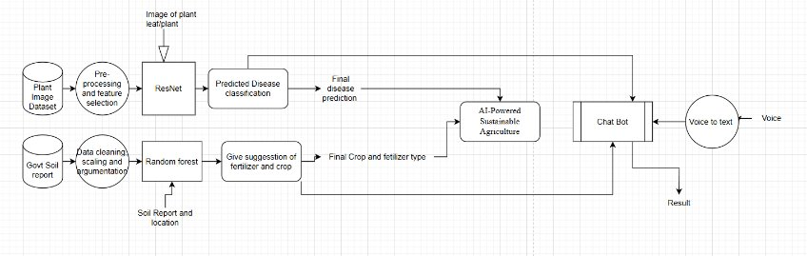

**Fig.3.1** Architecture Diagram

The architecture of the Smart Agriculture System is modular, scalable, and designed for ease of use in rural environments. It consists of four main layers: Input Layer, Processing Layer, AI/ML Modules, and Output Layer. Each component plays a crucial role in ensuring seamless data flow, decision-making, and user interaction.

**1. Input Layer (Data Collection Sources)**

This layer collects data from multiple sources:

* **User Input**: Farmers manually input crop/soil/weather data or upload images via a mobile/web interface.
* **Sensor/External APIs (Optional)**: For future scaling, IoT sensors can be integrated for real-time soil moisture, temperature, and humidity data.
* **Databases**: Static and dynamic datasets such as soil types, fertilizer content, crop calendars, and weather APIs are integrated.

**2. Processing Layer**

This layer handles data cleaning, validation, and pre-processing before feeding it into the ML models.

* **Data Preprocessing Unit**: Performs feature engineering, normalization, and missing value handling.
* **Image Preprocessing**: Converts uploaded leaf images into appropriate input formats for CNN-based models (resizing, normalization).
* **Language Processing**: Translates user queries into a standard format using NLP techniques.

**3. AI/ML Modules**

Each functionality is handled by a dedicated model:

* **Crop Recommendation Module**: Uses algorithms like Random Forest or Decision Tree based on parameters like soil nutrients, temperature, rainfall, and region.
* **Fertilizer Recommendation Module**: Matches nutrient deficiencies with required fertilizers using classification or rule-based models.
* **Disease Detection Module**: Utilizes CNNs (like ResNet or VGG) to identify diseases from leaf images.
* **Yield Prediction Module**: Implements LSTM or regression models for forecasting crop yield.
* **Multilingual Chatbot (NLP Module)**: Uses pretrained models (like BERT or Indic BERT) and translation APIs to support regional languages for conversational responses.

**4. Output Layer (Decision Support Interface)**

* **User Dashboard**: Displays recommendations for crop, fertilizer, yield estimate, and disease diagnosis.
* **Chatbot Interface**: Responds to natural language queries with voice/text support.
* **Notifications System**: Sends alerts about pests, seasonal advice, and weather-based recommendations.

**5. Technology Stack**

* **Frontend**: React.js / HTML5 for responsive interfaces.
* **Backend**: Python (Flask/Django) for API integration.
* **Machine Learning**: Scikit-learn, TensorFlow, or PyTorch.
* **Database**: SQLite / PostgreSQL for structured data.
* **Cloud**: (Optional) AWS/GCP for scalability and hosting models.
* **APIs**: Weather API, Translation API, Agriculture datasets.

**6. System Workflow Overview**

1. Farmer selects the feature (e.g., crop recommendation, chatbot).
2. User input (or image) is collected and pre-processed.
3. The relevant ML model processes the input and returns output.
4. Output is shown in a user-friendly format (text/image/voice).
5. Chatbot assists in queries throughout the user session.

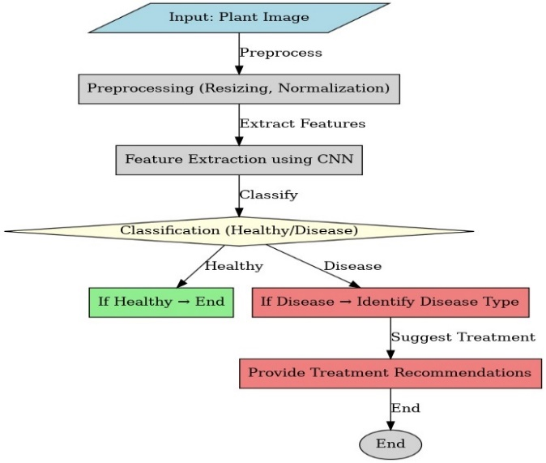

**Fig.3.2** Diagram Of Plant Disease Detection

The plant disease detection module employs a Convolutional Neural Network (CNN) to identify diseases in plant leaves using image classification. The diagram typically illustrates the following sequential flow:

1. **Image Input**: Farmers upload images of affected plant leaves through the system interface. These images are then preprocessed (resized, normalized, and augmented) to improve model robustness across lighting conditions and angles.
2. **Convolutional Layers**: These layers apply multiple filters to the image, detecting key features like discoloration, spots, and texture changes—common indicators of plant diseases. Each convolution operation extracts increasingly abstract patterns from the image.
3. **Pooling Layers**: These layers reduce the spatial dimensions of the convolved features using operations like max pooling. This step helps retain essential features while lowering computational complexity and preventing overfitting.
4. **Flattening**: The pooled feature maps are flattened into a single vector, preparing the data for the fully connected layers.
5. **Fully Connected Layers (Dense Layers)**: These layers learn the complex relationships between the extracted features and the target classes (disease types). They act as a classifier.
6. **Softmax Output Layer**: The final layer outputs the probability distribution over multiple disease classes, predicting the most likely disease the plant might have.
7. **Diagnosis & Recommendation**: Based on the predicted class, the system provides the farmer with the name of the disease and corresponding management suggestions, such as organic treatments or pesticide use

The architecture of the AI-powered Smart Agriculture System is designed as a modular and flexible framework that seamlessly integrates various technological components to ensure scalability, accuracy, and user accessibility. Each architectural layer is responsible for a distinct function but interacts cohesively with the others to enable the system to deliver reliable, real-time, and actionable insights to farmers across diverse agricultural landscapes.

At the foundation of the architecture lies the Data Layer, which serves as the primary interface for data collection. It aggregates real-time and historical data from multiple sources, including IoT-based soil sensors that measure parameters such as pH, moisture content, and macronutrient levels (NPK), as well as weather APIs that provide up-to-date forecasts on temperature, rainfall, and humidity. Additionally, this layer captures manual inputs from farmers, including textual queries, voice messages, and leaf images for disease analysis. Historical datasets on crop yields, fertilizer usage, and climate trends are also fed into the system for deeper analytical context.

Once data is collected, it flows into the Preprocessing Layer, where it undergoes a series of transformations to ensure quality and consistency. This includes data cleaning procedures to eliminate duplicates, outliers, and missing values, along with normalization techniques that standardize numerical data for optimal machine learning performance. In the case of image inputs for disease detection, this layer also applies augmentation techniques such as rotation, scaling, and brightness adjustment to increase model generalization. Furthermore, time-series alignment and encoding are performed for crop yield prediction to ensure that temporal patterns are accurately captured.

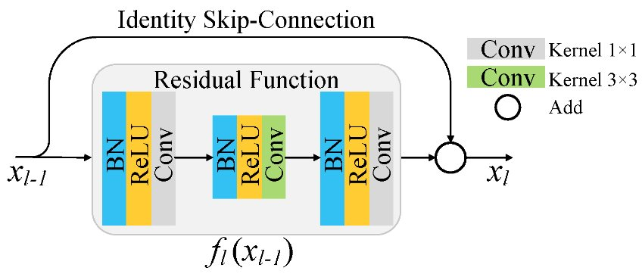

**Fig 3.3** Working Of ResNet9 Using Identity Skip Connection

Processed data is then passed into the Modeling Layer, which is the analytical engine of the system. This layer hosts a suite of AI models that drive core functionalities. A Random Forest algorithm is employed for crop and fertilizer recommendation, leveraging soil characteristics, climate data, and historical cropping patterns to suggest optimal planting and nutrient strategies. An LSTM (Long Short-Term Memory) network is used for yield forecasting by analyzing multi-year climatic and agronomic time-series data. For plant disease detection, a ResNet9 deep learning model processes leaf images and classifies them with high accuracy into disease categories, offering early warning and treatment options. These models are carefully trained and fine-tuned using domain-specific data to ensure robustness and adaptability across different agro-climatic zones.

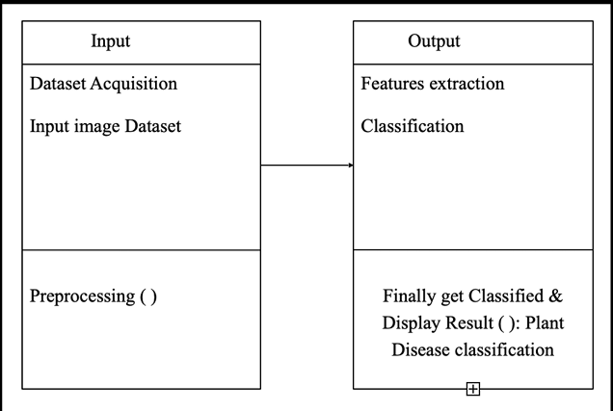

**Fig 3.4** Working Of Plant Disease Detection Model

To ensure that these AI-driven capabilities are accessible to users in an intuitive manner, the Interaction Layer is implemented as the communication interface between the system and farmers. This layer supports both text and speech-based inputs via a multilingual chatbot. Built using mBERT and integrated with speech-to-text APIs, the chatbot enables farmers to engage with the system in their native languages, overcoming barriers related to literacy and digital proficiency. The chatbot is capable of understanding agricultural terminology and user intent, providing contextual responses about crop recommendations, fertilizer schedules, weather alerts, and disease management.

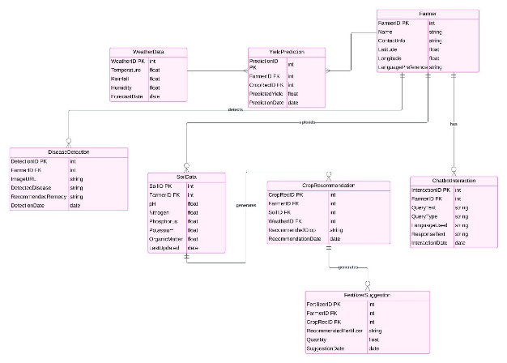

**Fig 3.5** Class Diagram Of All The Entities

Following model execution, the Analytics Layer takes the outputs from the Modeling Layer and processes them for end-user interpretation. This includes generating visual dashboards that display yield forecasts, soil nutrient statuses, and disease detection summaries. Reports are dynamically updated based on real-time data inputs and are presented in a user-friendly format through mobile or web applications. The analytics interface helps farmers and agronomists quickly assess current conditions, monitor crop health, and plan interventions effectively.

Finally, the system architecture is supported by the Deployment Layer, which ensures that the entire platform operates efficiently in both connected and offline environments. A hybrid deployment strategy combining cloud computing and edge computing is adopted. High-computation tasks, model training, and data storage are managed through cloud services, while edge devices—such as mobile phones or local servers—enable on-field inference and decision-making even in areas with poor internet connectivity. This dual approach not only enhances scalability and performance but also ensures that the system remains functional and accessible in rural and remote farming regions.

In summary, the modular architecture of the system promotes robustness, flexibility, and ease of use. It ensures that complex AI functionalities are delivered seamlessly to end users, translating advanced analytics into practical farming decisions. This layered design supports continuous learning and system evolution, paving the way for broader adoption of smart agriculture practices and sustainable food production.

**3.4 Data Preprocessing and Feature Engineering**

Data preprocessing plays a pivotal role in the performance and accuracy of machine learning models, particularly in agricultural applications where data is often collected from varied sources with different formats and quality. The goal of this stage is to transform raw data into a clean, consistent, and structured format suitable for training robust and generalizable models. The preprocessing pipeline for this AI-powered Smart Agriculture System is designed to handle both structured tabular data (e.g., soil and weather data) and unstructured data (e.g., plant disease images).

A key component of the preprocessing process involves handling missing or incomplete values, which are common in datasets collected from sensor networks, farmer inputs, or public agricultural repositories. To address this, K-Nearest Neighbors (KNN) imputation is employed. This technique estimates missing values based on the similarity of a given record to its nearest neighbors. For example, if a farmer’s soil nitrogen value is missing, KNN can predict it by analyzing other farmers' data with similar pH, moisture, or phosphorus levels. This method ensures that the data remains realistic and consistent, improving downstream model performance without introducing significant bias.

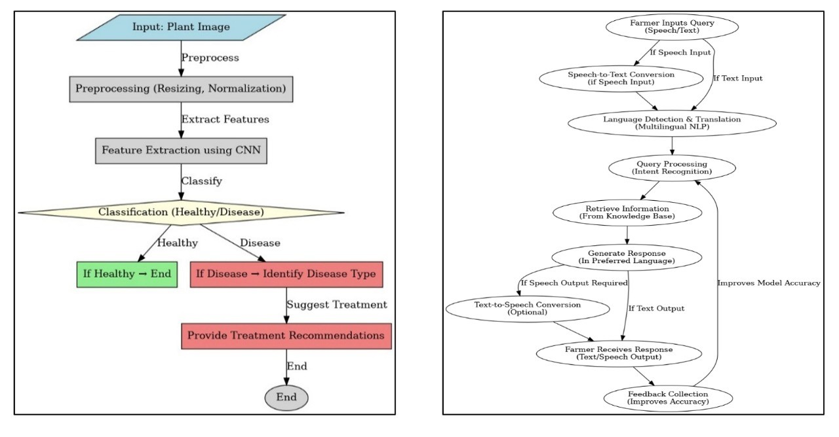

**Fig 3.6,3.7** The Flow Chart Of Chatbot And Plant Disease

Another important step in the preprocessing workflow is the identification and treatment of outliers. Outliers can distort the learning process, especially for algorithms sensitive to distance metrics. Two widely used statistical methods—Z-score normalization and the Interquartile Range (IQR) technique—are implemented for outlier detection. The Z-score method flags values that lie a certain number of standard deviations away from the mean, while the IQR method targets values outside the upper and lower quartiles of the data distribution. Once identified, outliers can either be removed or replaced using appropriate smoothing or interpolation strategies, depending on the nature and importance of the data point.

Following outlier handling, feature scaling is applied to standardize the range of numerical variables. This is crucial because machine learning models like Random Forests and LSTM networks can be influenced by differences in feature magnitude. The system employs Min-Max normalization, which rescales all features to a fixed range, typically [0, 1]. For instance, features like rainfall (measured in mm) and pH (a unitless value) are scaled to the same range so that they contribute equally during training. This not only accelerates convergence but also prevents models from favoring variables with higher numerical ranges.

To further enhance model performance and reduce computational complexity, Principal Component Analysis (PCA) is incorporated for dimensionality reduction. In scenarios where datasets contain a large number of interrelated features—such as multiple weather indicators or soil nutrients—PCA transforms the data into a smaller set of uncorrelated variables called principal components. These components retain most of the variance in the original data while removing redundancy, thereby simplifying the learning process without significantly compromising accuracy.

In addition to preprocessing structured data, specialized techniques are used to prepare image datasets for the plant disease detection module. Since deep learning models like ResNet9 require large and diverse datasets for effective training, image augmentation techniques are applied to increase variability and prevent overfitting. These include:

* Rotation, to simulate leaves captured at different angles.
* Flipping (horizontal and vertical), to reflect natural leaf orientations.
* Contrast and brightness adjustment, to account for lighting variations during image capture.
* Scaling and zooming, to simulate different camera distances and resolutions.

These augmentations effectively multiply the size and diversity of the training dataset, improving the CNN model’s ability to generalize across unseen leaf images and conditions.

Overall, the preprocessing pipeline is designed to be robust, adaptive, and scalable. It ensures that data fed into the system’s models is high-quality, noise-free, and representative of real-world agricultural scenarios. By combining advanced statistical techniques with domain-specific enhancements, the system maximizes predictive accuracy while ensuring model stability and interpretability.

**3.5 Modeling Layer**

The modeling layer forms the core intelligence of the AI-powered Smart Agriculture System. This layer hosts and orchestrates the execution of advanced Machine Learning (ML) and Deep Learning (DL) models, each dedicated to a specific aspect of agricultural decision-making. These models are responsible for performing complex analyses on processed data and generating accurate, real-time predictions and recommendations that directly support farmers in their daily operations. The models are trained and validated using real-world agricultural datasets, and optimized through state-of-the-art techniques to ensure both precision and generalizability.

At the heart of crop selection and fertilizer optimization lies the Random Forest (RF) algorithm. RF is a robust ensemble learning technique that constructs multiple decision trees during training and aggregates their outputs to deliver reliable predictions. In the context of this system, RF is trained on features such as soil nutrient levels (N, P, K), pH, temperature, rainfall, and historical yield data. By analyzing these inputs, the model identifies the most suitable crop for a given location and soil condition. It also suggests the optimal type and quantity of fertilizer required to balance nutrient levels and promote healthy plant growth. The strength of Random Forest lies in its ability to handle both numerical and categorical variables, manage missing values gracefully, and resist overfitting, making it ideal for heterogeneous agricultural datasets.

For crop yield forecasting, the system employs Long Short-Term Memory (LSTM) networks, a specialized class of Recurrent Neural Networks (RNNs) designed to model temporal dependencies in sequential data. LSTMs are particularly effective in agriculture because they can learn long-term patterns from time-series data, such as historical yields, seasonal weather trends, temperature fluctuations, and rainfall distributions. By capturing these trends, the LSTM model predicts the expected yield for a selected crop, helping farmers and policymakers in resource allocation, storage planning, and market readiness. Unlike traditional regression models, LSTMs excel in handling irregular data sequences and fluctuating environmental patterns, making them highly suitable for the dynamic nature of agricultural forecasting.

The system’s ability to detect plant diseases early and accurately is driven by ResNet9, a variant of the Residual Neural Network (ResNet) architecture used in computer vision. ResNet9 is a deep Convolutional Neural Network (CNN) that addresses the vanishing gradient problem found in traditional deep networks by using skip connections that allow gradients to flow directly through the network. This enables it to learn highly discriminative features from image data. Using transfer learning, the ResNet9 model is pre-trained on a large dataset of plant disease images (e.g., from the PlantVillage dataset) and then fine-tuned on the specific target crops. Farmers can upload pictures of affected leaves via a mobile interface, and the model classifies the image to determine the presence and type of disease (e.g., powdery mildew, rust, blight), providing treatment suggestions. The model demonstrates high classification accuracy, even under varying lighting conditions and image quality, thanks to prior augmentation and training techniques.

To enhance model performance, optimization techniques are employed during training. Grid search is used to identify the best hyperparameters, such as the number of trees in Random Forest, LSTM cell size, learning rates, and batch sizes. Dropout regularization is implemented, especially in LSTM and CNN models, to prevent overfitting by randomly dropping units during training. This forces the network to learn redundant representations and improves generalization. In addition, all deep learning models are trained using adaptive optimizers, with Adam (Adaptive Moment Estimation) being the primary choice. Adam combines the advantages of both AdaGrad and RMSProp, making it well-suited for handling sparse gradients and noisy data—conditions common in agricultural datasets.

Together, these models form a powerful and complementary suite of AI tools that drive the decision-making capabilities of the Smart Agriculture System. Each model is integrated into the larger system architecture via APIs and is continuously improved based on new data and farmer feedback, ensuring the platform remains adaptive, scalable, and effective in real-world farming conditions.

**3.6 Explainability Layer**

A key barrier to the widespread adoption of AI systems in agriculture is the lack of transparency in how predictions and recommendations are generated. To address this concern and foster trust among farmers and agricultural stakeholders, the proposed system incorporates a dedicated Explainability Layer that leverages Explainable Artificial Intelligence (XAI) techniques. This layer is designed to provide clear, human-understandable interpretations of the outputs produced by the system’s various machine learning and deep learning models.

For crop and fertilizer recommendations powered by Random Forest algorithms, feature importance scores are visualized to show which soil or environmental factors most influenced a particular recommendation. This helps farmers understand, for instance, whether soil nitrogen deficiency or low rainfall was the driving factor behind a crop suggestion. In the case of plant disease detection using deep convolutional networks like ResNet9, the system integrates saliency maps and Grad-CAM (Gradient-weighted Class Activation Mapping) to visually highlight which regions of a leaf image contributed most to the model's classification. These visual cues can validate the presence of disease symptoms, reassuring users about the system’s diagnostic accuracy.

For time-series predictions such as crop yield forecasting using LSTM networks, attention mechanisms are applied to identify and highlight the most influential time steps in the historical data that affected the forecast. This allows stakeholders to trace the reasoning behind a predicted yield spike or drop back to specific weather events or past cropping patterns. Together, these XAI techniques enhance transparency and interpretability, ultimately increasing user confidence in AI-assisted decisions and promoting more informed and engaged farming practices.

**3.7 Visualization and Reporting Layer**

The Visualization and Reporting Layer serves as the user-facing interface for interpreting and analysing system outputs. It is designed to transform complex model results into intuitive, easy-to-understand visual formats that support timely decision-making by farmers, agronomists, and agricultural planners. Interactive dashboards are developed to provide real-time visibility into several key indicators, including recommended crop and fertilizer combinations based on current soil and weather conditions, predicted crop yield trajectories over time, and the identification and classification of plant diseases from uploaded images.

In addition to presenting model outputs, the dashboards also display dynamic environmental data such as temperature, humidity, rainfall forecasts, and soil health indicators collected from sensor networks and API integrations. These dashboards can be accessed via mobile applications or web interfaces, ensuring accessibility even in low-resource environments. The layer is equipped with tools to generate automated and customizable reports, which summarize system performance, prediction accuracy, and decision outcomes over a defined period. These reports assist farmers in planning seasonal activities, evaluating intervention effectiveness, and maintaining records for future reference or compliance with agricultural programs. By offering a centralized and visual platform for monitoring and analysis, this layer ensures that insights generated by the system are actionable, transparent, and aligned with the **user’s operational needs.**

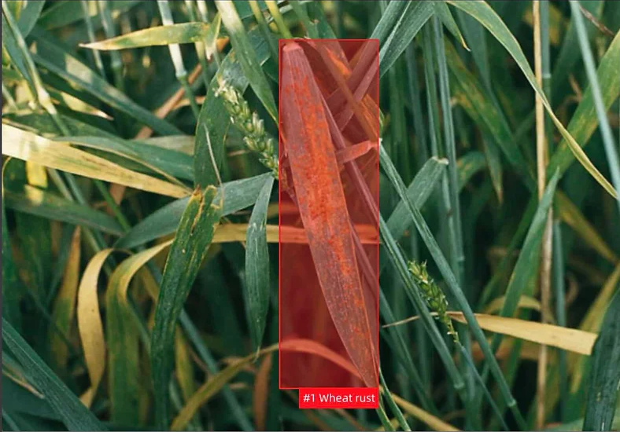

**Fig 3.8** Machine Learning Algorithms To Analyse Images Of Wheat Fields

**3.8 Scalability and Deployment Considerations**

To support widespread adoption and ensure reliable operation across diverse agricultural contexts, the system is architected with scalability and deployment flexibility in mind. A hybrid cloud-edge computing model has been implemented to balance computational efficiency with on-ground accessibility. Edge computing devices, such as smartphones or embedded microcontrollers, are deployed in remote farming locations to handle real-time data processing and inference tasks. These devices enable the system to function effectively even in areas with limited or intermittent internet connectivity by supporting offline operations and local decision-making.

Meanwhile, cloud servers manage more resource-intensive functions, including large-scale model training, centralized data storage, analytics, and periodic model updates. This separation of concerns enhances the system’s overall performance and ensures that high-computation tasks do not overwhelm edge resources. To support deployment on mobile and embedded systems, models are optimized using techniques like pruning and quantization, which reduce model size and inference time without significantly compromising accuracy.

Furthermore, federated learning has been integrated into the deployment strategy to allow decentralized model training. This approach enables individual devices to train local models using on-site data and share only the updated parameters with the cloud server. As a result, the system maintains data privacy and security while continually improving its global performance based on distributed learning. This deployment design ensures that the system can scale across regions and user bases, adapting to varying connectivity, hardware, and environmental conditions.

**3.9 Summary**

The proposed system architecture effectively addresses the complex demands of modern agriculture by integrating advanced AI technologies with real-time analytics, multilingual interaction, and scalable infrastructure. Each architectural layer contributes to a cohesive ecosystem that is intelligent, adaptive, and user-friendly. By combining a modular design with hybrid deployment capabilities, the system ensures that farmers—regardless of geographic, economic, or technical limitations—have access to powerful tools for making data-driven agricultural decisions. The inclusion of explainability and visualization mechanisms further strengthens user trust, facilitates transparent decision-making, and enables farmers to understand the rationale behind AI-generated insights.

Moreover, the system architecture is built to accommodate continuous learning and system evolution. It supports modular plug-ins for future integration of additional features such as satellite data processing, drone-based field monitoring, and weather-risk assessment models. With edge computing components integrated for offline processing and cloud modules for large-scale data analysis, the infrastructure ensures high availability and responsiveness even in low-connectivity rural regions. The architecture also emphasizes secure data flow and privacy, incorporating role-based access and encrypted communication to protect sensitive agricultural data.

Overall, the architecture positions the Smart Agriculture System as a comprehensive and forward-looking solution that supports precision farming, sustainable food production, and the democratization of AI in agriculture. It serves not only as a tool for individual productivity but also as a collective intelligence platform that can inform policy, market strategy, and environmental planning on a regional and national scale.

As AI deepens its roots in agriculture, we are witnessing the dawn of a smarter, more efficient, and sustainable era of farming. Let us explore some of the key technologies powering this transformation and how they are revolutionizing traditional agricultural practices:

Crop Disease Detection using convolutional neural networks (CNNs) enables early diagnosis, minimizing yield loss and reducing chemical usage.

Predictive Analysis for Crop Yield, driven by time-series models like LSTM and environmental sensor data, allows for more accurate planning and resource optimization.

Supply Chain and Demand Forecasting leverages machine learning algorithms to anticipate market trends, improve logistics, and reduce post-harvest losses through better inventory management.

These components collectively underscore the pivotal role of AI in shaping the future of agriculture—from the soil to the shelf.

**CHAPTER 4**

**METHODOLOGIES**

**4.1 Modules**

**1. Input Data Module**

* Collects historical crop yield, soil composition, and fertilizer usage data.
* Fetches real-time weather data such as temperature, humidity, and rainfall via

APIs.

* Gathers soil sensor data including pH, Nitrogen (N), Phosphorus (P), and Potassium (K) levels.
* Accepts farmer-submitted data through manual entries, voice queries, and leaf images.

**2. Data Preprocessing Module**

* Applies Min-Max Normalization to scale numerical features between 0 and 1.
* Handles missing data using K-Nearest Neighbors (KNN) imputation.
* Uses PCA (Principal Component Analysis) to reduce dimensionality of large datasets.
* Augments images by rotating, flipping, and adjusting contrast to improve CNN robustness.

**3. Crop and Fertilizer Recommendation Module**

* Uses Random Forest algorithm to recommend the best crop for given conditions.
* Analyzes soil nutrients, weather, and crop history for tailored suggestions.
* Calculates fertilizer needs based on NPK deficiency using nutrient gap analysis.
* Provides specific fertilizer formulas to optimize soil health and productivity.

**4. Crop Yield Prediction Module**

* Implements Long Short-Term Memory (LSTM) for forecasting crop yields.
* Utilizes historical yield records and real-time climate data as input.
* Optimizes model performance using dropout layers, Adam optimizer, and grid search.
* Predicts yield outcomes to aid planning for harvesting and supply.

**5. Plant Disease Detection Module**

* Employs Convolutional Neural Network (CNN) to classify plant leaf images.
* Detects texture, lesions, and discoloration to identify diseases.
* Uses transfer learning and cross-entropy loss to improve classification accuracy.
* Outputs disease name and suggests corresponding treatment or pesticide.

**6. Multilingual Chatbot Interface Module**

* Integrates Natural Language Processing (NLP) to interpret farmer queries.
* Supports multiple languages and dialects through speech-to-text and text-to-speech.
* Uses TF-IDF and word embeddings to generate relevant responses.
* Provides real-time guidance on crops, fertilizers, diseases, and weather.

**7. Real-Time Weather Adaptation Module**

* Continuously pulls weather data from APIs.
* Modifies crop and fertilizer recommendations based on upcoming conditions.
* Sends alerts for adverse weather that may affect plant health.
* Enhances accuracy of yield prediction and disease forecasts.

**8. Data Integration & Storage Module**

* Integrates inputs from sensors, APIs, images, and user interactions.
* Uses cloud and local storage to manage datasets.
* Ensures data persistence for model updates and user history.
* Supports batch and real-time data processing.

**9. Continuous Learning & Feedback Module**

* Learns from user feedback, updated inputs, and environmental changes.
* Applies reinforcement and active learning techniques.
* Refines model outputs over time based on actual farming outcomes.
* Improves chatbot relevance and prediction accuracy with continuous use.

**10. Scalability & Edge Deployment Module**

* Uses model compression to reduce size and memory usage.
* Enables real-time predictions on mobile or low-power devices.
* Uses edge computing to reduce cloud dependency in remote areas.
* Ensures uninterrupted service even in low-connectivity environments.

**4.2 Data Acquisition and Preparation**

In the development of the AI-powered Smart Agriculture System, the process of data acquisition and preparation forms the backbone of the entire modelling pipeline. Accurate, comprehensive, and diverse datasets are crucial to train reliable machine learning and deep learning models. The system incorporates both structured and unstructured data from multiple sources to ensure that the resulting models are context-aware and capable of providing location-specific, real-time recommendations.

The first category of data involves soil health records, which include parameters such as pH, electrical conductivity, moisture levels, and nutrient concentrations—specifically Nitrogen (N), Phosphorus (P), and Potassium (K). These records are collected via in-field soil testing kits, sensor networks, or agronomic surveys and are essential for determining crop suitability and fertilizer requirements.

Historical weather datasets are sourced from meteorological departments and agricultural research bodies. These datasets include daily and seasonal records of temperature, humidity, rainfall, and wind speed over multiple years. Additionally, the system is integrated with real-time weather APIs that provide current and forecasted environmental data. This real-time feed allows the models to dynamically adjust their recommendations based on sudden changes in weather patterns, improving adaptability and resilience.

Farmer-submitted logs provide critical human-centred insights into actual crop cycles, fertilizer usage, irrigation schedules, and pest control practices. These inputs are gathered through the multilingual chatbot interface, mobile forms, or through direct integration with local agricultural extension services. Such data enhances personalization and allows the system to cater to individual farm-level conditions.

For disease detection, the system utilizes plant disease image datasets, primarily obtained from Kaggle repositories such as the Plant Village dataset. These are supplemented with field-sourced images collected via mobile phones during pilot studies. The images cover a wide range of crops, diseases, and environmental lighting conditions to ensure model robustness across real-world scenarios.

The combined dataset is subjected to an initial cleaning process that includes de-duplication, handling missing values, resolving inconsistencies, and standardizing formats. Data is then stored in structured formats (CSV, JSON) within a centralized, scalable cloud storage infrastructure, ensuring easy access and efficient retrieval during model training and inference.

**4.3 Feature Engineering**

Feature engineering is a critical phase in the machine learning pipeline, where raw data is transformed into meaningful representations that improve model performance and predictive power. For this system, both manual and automated feature engineering techniques were employed.

One of the key engineered features is the creation of soil fertility indices, which combine multiple soil parameters into a composite score. These indices help rank fields by nutrient richness and suitability for different crop types. The system also computes climatic suitability scores for crops by analysing the interaction between soil type, rainfall, temperature, and seasonal patterns. These scores are essential for crop recommendation tasks.

To enhance the LSTM-based yield prediction module, temporal encoding of weather sequences is applied. This involves capturing seasonality, trends, and anomalies in multivariate time-series data such as daily rainfall and temperature over several years. The encoded sequences enable the model to learn long-term dependencies that are vital for accurate yield forecasting.

In the case of image data used for disease detection, the system extracts leaf-specific features including colour histograms, texture patterns, edge density, and lesion area. These features are used to train the convolutional layers of the ResNet9 model and aid in distinguishing between healthy and infected regions. Image augmentation techniques—such as rotation, flipping, and contrast enhancement—are also part of this process, increasing data diversity and model generalization.

**4.4 Model Development and Training**

The core intelligence of the system lies in its well-trained and fine-tuned models, each selected based on the problem type and data structure. For crop and fertilizer recommendation, Random Forests were chosen due to their interpretability and robustness against overfitting. These models were trained on a diverse agricultural dataset that included soil test results, climatic conditions, and historical crop performance. The ensemble nature of Random Forests ensures stable and high-accuracy outputs.

For crop yield prediction, Long Short-Term Memory (LSTM) networks were employed. LSTM’s ability to capture temporal dependencies makes it well-suited for this task, where past yields, seasonal patterns, and weather trends significantly influence future output. The models were trained using multi-year data sequences, and dropout layers were added to prevent overfitting.

For plant disease classification, a ResNet9 architecture was fine-tuned using transfer learning. The base model was pre-trained on general image datasets and then adapted to recognize agricultural disease patterns using a curated set of leaf images. This approach reduced training time while maintaining high classification accuracy across various diseases and lighting conditions.

Model training was carried out using stratified data splits and validated through cross-validation techniques. Hyperparameter tuning was conducted using grid search to identify optimal values for tree depth, learning rates, batch sizes, and the number of epochs. Early stopping criteria were applied to prevent overfitting and optimize model generalization.

**4.5 Explainability Integration**

To ensure transparency and foster user trust, explainability mechanisms were built into every component of the system. For Random Forests, feature importance heatmaps were generated to visually highlight the most influential variables in determining crop or fertilizer recommendations. These maps allow farmers and agronomists to understand why a particular decision was made, thus increasing adoption and confidence.

In the deep learning modules, particularly ResNet9 for disease detection, Grad-CAM (Gradient-weighted Class Activation Mapping) was used to overlay attention maps on the leaf images. This visualization shows which regions of the image the model focused on when making a classification, helping users verify if the model is correctly identifying lesions or discolorations.

For LSTM-based yield prediction, saliency analysis was applied to track which time points in the input sequence contributed most to the output prediction. This technique helps identify key historical weather events or soil conditions that influenced the model’s decisions.

All explainability outputs are integrated into the user interface through the chatbot or dashboard, allowing farmers to query and view not just the recommendations but also the rationale behind them. This transparency fosters user engagement, educates farmers, and encourages data sharing for continuous model improvement.

**4.6 Evaluation and Validation**

Rigorous evaluation protocols were established to ensure the reliability, accuracy, and fairness of the models before deployment. Each model underwent stratified cross-validation, ensuring that the training and validation sets preserved the underlying data distribution across multiple folds. This process allowed for robust estimation of model performance metrics across diverse scenarios.

For classification tasks—such as disease detection and crop recommendation—key performance indicators included Accuracy, Precision, Recall, and F1-Score. These metrics helped balance false positives and false negatives, which is crucial in scenarios where misclassifications can lead to crop loss or incorrect input usage.

For regression tasks like yield prediction, the primary evaluation metric was Root Mean Squared Error (RMSE), which quantifies the average deviation between predicted and actual yields. RMSE was chosen for its sensitivity to large errors, ensuring that significant prediction deviations were accounted for during optimization.

The performance of the multilingual chatbot was also evaluated, particularly focusing on intent recognition accuracy and language translation quality. Test queries in different languages were analysed to assess whether the chatbot could understand and respond appropriately to user questions. Evaluation results showed high accuracy in both linguistic understanding and recommendation relevance.

Overall, the models demonstrated strong generalization capabilities and were deemed ready for deployment in real-world agricultural settings. Continuous evaluation is part of the system’s lifecycle, with user feedback loops integrated to further improve model accuracy and usability over time.

Looking ahead, the Smart Agriculture System is positioned to evolve significantly with the integration of advanced AI paradigms, cross-disciplinary data sources, and participatory design methodologies. One major area of future development lies in leveraging geospatial data and satellite imagery for precision agriculture. By combining high-resolution multispectral and hyperspectral imagery with existing soil and crop datasets, the system can identify subtle changes in vegetation health, detect early signs of pest infestation, and monitor irrigation effectiveness. This will allow farmers to receive hyper-localized recommendations, increasing resource efficiency and yield predictability. Furthermore, advances in edge AI and federated learning will support privacy-preserving, distributed model training across multiple user devices. This ensures that model improvements can be derived from a broad user base without compromising individual data security—making the platform more robust, fair, and inclusive. In parallel, blockchain technology can be introduced for secure data sharing and provenance tracking, especially beneficial in cooperative farming and crop traceability scenarios. The integration of IoT and smart sensor technologies will also open new possibilities for closed-loop feedback systems, where real-time field data continuously updates predictive models and alters recommendations dynamically. For example, if a sensor detects a sudden drop in soil moisture, the system could automatically adjust irrigation schedules, notify the farmer, and factor this anomaly into its yield projection model. Similarly, disease risk assessments could be updated hourly based on microclimate sensor feedback and visual cues captured via drone-mounted cameras. In terms of social and economic scalability, partnerships with government agricultural departments, rural extension officers, and NGOs will be critical. Through such collaborations, the system can be rolled out in regional languages, incorporate local knowledge bases, and be adapted to culturally relevant farming practices. Educational modules embedded within the chatbot can guide farmers on sustainable practices like crop rotation, organic alternatives, or conservation agriculture techniques. Eventually, the vision extends beyond a decision-support system into a holistic digital farming ecosystem—where AI, remote sensing, participatory data input, and real-time adaptation converge to create resilient, sustainable, and economically viable agricultural models. This future-ready architecture ensures that the Smart Agriculture System not only addresses the current pain points of the agricultural community but also remains adaptable and forward-compatible with the rapidly evolving technological and environmental landscape.

**CHAPTER 5**

**RESULTS AND DISCUSSIONS**

**5.1 Result**

The suggested AI-powered agriculture system has demonstrated substantial potential in enhancing decision-making for farmers through the integration of cutting-edge machine learning models and real-time data processing. Random Forest algorithm for crop and fertilizer recommendation has proven highly effective in generating accurate and context-aware suggestions based on environmental factors such as soil health, climate, and historical agricultural data. This model’s robustness across diverse datasets underscores its applicability to a wide range of agricultural settings, making it a valuable tool for precision farming. By analyzing multiple variables simultaneously, the system ensures that farmers receive well-informed recommendations tailored to their specific land conditions. The system’s ability to optimize resource allocation and minimize fertilizer misuse contributes to sustainable agricultural practices, ultimately enhancing farm profitability and reducing environmental impact.

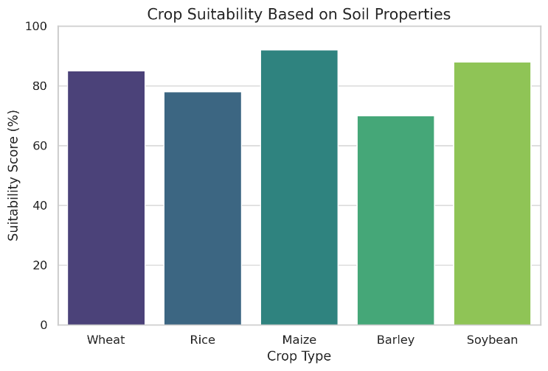

**Fig 5.1.** Crop suitability analysis based on soil properties, comparing suitability scores for different crop types

In the domain of crop yield prediction, the Long Short-Term Memory (LSTM) model has demonstrated significant efficacy in forecasting harvest outcomes based on historical agricultural trends and environmental parameters. The model effectively captures temporal dependencies between weather patterns and crop yields, providing farmers with reliable projections for upcoming harvests. By leveraging these insights, farmers can plan their irrigation schedules, labor management, and market strategies more efficiently. This predictive capability plays a very important role in mitigating risks, that are associated with unpredictable weather conditions and fluctuating market demands. Also, the integration of live weather data ensures that the model continuously refines its predictions, making it adaptable to dynamic environmental conditions.

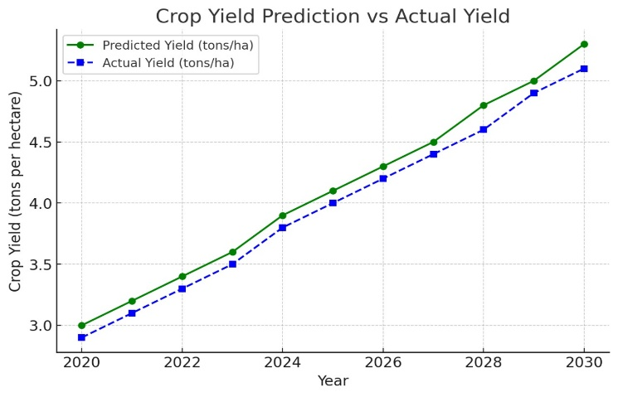

**Fig 5.2.** Crop yield prediction vs actual yield over time, illustrating model accuracy in forecasting agricultural productivity

Another crucial component of the system is the Convolutional Neural Network (CNN)-based plant disease detection module, which plays a pivotal role in enhancing the accuracy and efficiency of crop health monitoring. This module utilizes deep learning techniques to analyze high-resolution images of plant leaves and detect visual symptoms of disease such as discoloration, spots, mold growth, and texture changes. The CNN architecture is designed to extract intricate features from these images through multiple convolutional layers, enabling the system to learn complex patterns associated with various plant diseases.

The model is trained on comprehensive and well-curated datasets that include a diverse array of plant species and an extensive catalog of plant diseases. These datasets often contain thousands of labeled images captured under different lighting conditions, angles, and environmental scenarios, allowing the model to learn robust and generalizable features. As a result, the CNN can accurately identify disease symptoms even when presented with previously unseen data from different agricultural settings or climatic conditions.

By enabling early and accurate disease detection, the system provides farmers with actionable insights at a critical time—before the disease spreads and causes significant damage. This early intervention capability is instrumental in improving crop yield and quality, as it allows for timely application of targeted treatments such as fungicides or pesticides, thereby reducing unnecessary chemical usage and associated costs.

In contrast to traditional plant disease diagnosis methods, which often depend on expert agronomists or pathologists to visually inspect and diagnose plant conditions, the proposed system automates the diagnostic process. This is especially valuable in rural and underserved regions, where access to agricultural experts may be limited or delayed. By leveraging machine learning, the system democratizes access to expert-level diagnostic capabilities, making sophisticated plant health assessments available to farmers through a simple mobile interface or an integrated smart farming platform.

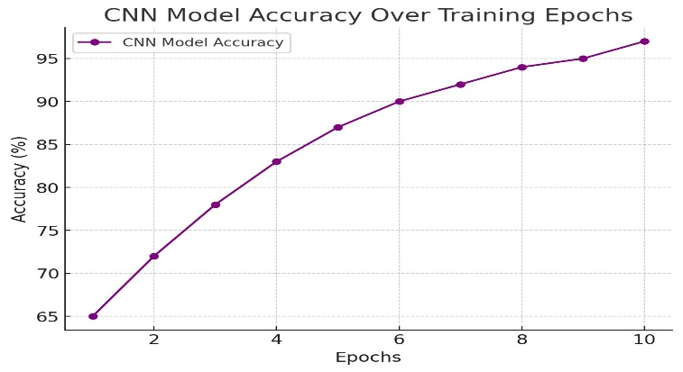

**Fig 5.3**. CNN Model Accuracy Over Training Epochs

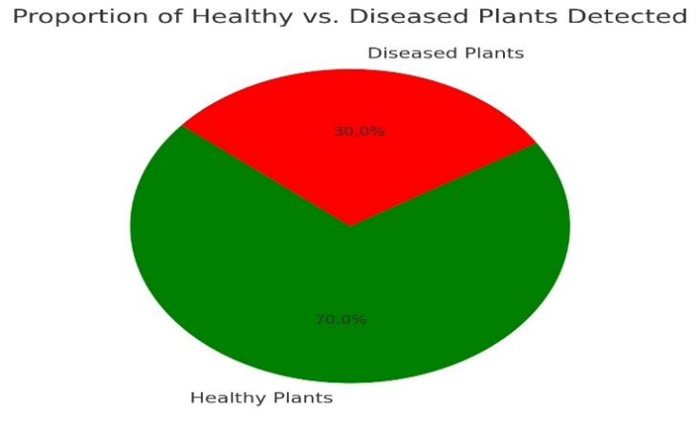

**Fig 5.4.** Proportion of Healthy vs. Diseased Plants Detected – A pie chart showing the percentage of healthy and diseased plants

The implementation of a multilingual chatbot, powered by Natural Language Processing (NLP), has significantly enhanced the system’s accessibility, particularly for farmers in linguistically diverse regions. The chatbot facilitates seamless interaction between farmers and the system, allowing them to obtain information on crop recommendations, disease management strategies, and optimal fertilizer use. By supporting both text and speech inputs, the chatbot accommodates farmers with varying levels of digital literacy, ensuring that they can engage with the system effortlessly. Furthermore, the integration of speech-to-text technology enhances usability for farmers who may be more comfortable with verbal communication than text-based interactions.

The multilingual chatbot feature, supported by NLP techniques, has enhanced the accessibility of the system for farmers who may not be fluent in major languages. By providing a conversational interface for farmers to query crop recommendations, disease management tips, and fertilizer usage, the chatbot facilitates real-time, hands-on assistance. Farmers can interact with the system through voice or text input, making the technology more user-friendly. The NLP model has also been trained to adapt to the diverse dialects and linguistic patterns of farmers, ensuring that the system can effectively communicate with a broader user base.

A key strength of the NLP-based chatbot is its ability to adapt to regional dialects and linguistic variations, making it an inclusive tool for diverse agricultural communities. The chatbot’s responses are generated based on an extensive agricultural knowledge base, allowing it to provide contextually relevant and evidence-based guidance. The interactive nature of the chatbot fosters continuous engagement with farmers, enabling them to seek real-time support for their farming challenges. Moreover, by analysing user interactions, the chatbot refines its responses over time, improving its accuracy and relevance with continued use.

Despite the system’s strong performance, certain challenges were observed during its implementation, particularly concerning data variability. The performance of machine learning models relies heavily on the accuracy and reliability of the input data. While the system performed well on pre-collected datasets, its adaptability to different farming conditions remains an area requiring further improvement. Agricultural environments vary significantly across regions due to differences in soil composition, climatic conditions, and cultivation practices. Consequently, continuous updates and region-specific training datasets are essential to maintaining the system’s accuracy and reliability. 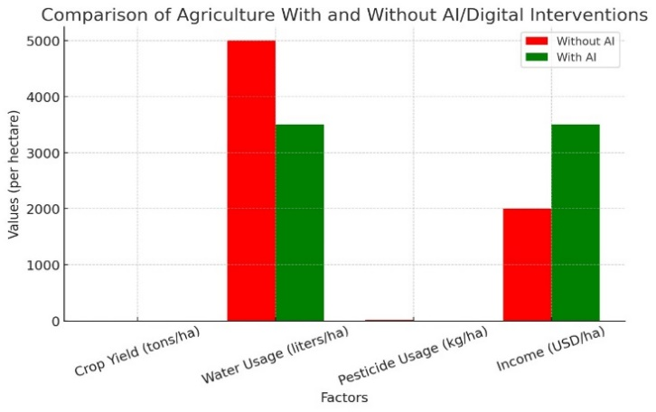

**Fig 5.5.**  AI in Agriculture Performance Comparison A bar chart comparing agricultural factors (crop yield, water usage, pesticide usage, and income) with and without AI intervention

Another limitation of the system pertains to its reliance on real-time weather data and mobile-based imagery for disease detection. In rural areas with limited internet connectivity, the availability of high-quality data may be inconsistent. Farmers using low-resolution mobile cameras may face challenges in capturing clear images for disease diagnosis, potentially affecting model accuracy. Addressing these limitations requires integrating additional data sources, such as satellite imagery and localized weather stations, to enhance the robustness of the system. Furthermore, optimizing the system for offline functionality could improve accessibility in areas with poor connectivity.

To further enhance the system’s effectiveness, future research will focus on improving the flexibility of machine learning models through reinforcement learning and active learning techniques. These approaches will allow the system for dynamically adjusting its predictions based upon real-time user interactions and evolving agricultural conditions. Additionally, expanding the chatbot’s knowledge base to include region-specific agricultural practices and indigenous farming wisdom can improve its contextual relevance. By incorporating these advancements, the system can evolve into a more intelligent and adaptive tool that supports sustainable agricultural development.

Overall, the AI-powered agriculture system marks a major step forward in agricultural technology by integrating advanced predictive algorithms, real-time data analysis and an intuitive chatbot interface. The system’s ability to provide actionable insights in multiple languages and formats enhances its usability for farmers across diverse regions. While certain challenges remain in terms of data variability and real-time processing constraints, ongoing improvements in data integration and model adaptability will further strengthen the system’s impact. By bridging the gap between technology and agriculture, this system has the potential to empower farmers with data-driven decision-making tools, fostering improved productivity, sustainability, and economic resilience in the agricultural sector.

**5.2 Model Performance Comparison**

The performance of different models used in the Smart Agriculture System, such as crop yield prediction, disease detection, and chatbot accuracy, has been compared. The table below presents key metrics for each model, showcasing their performance.

| **Model** | **Accuracy (%)** | **Precision (%)** | **Recall (%)** | **F1-Score (%)** | **Mean Absolute Error (MAE)** |
| --- | --- | --- | --- | --- | --- |
| **LSTM** | 85.7 | 87.2 | 84.5 | 85.8 | 2.5 |
| **Random Forest** | 82.4 | 81.1 | 83.2 | 82.0 | 3.0 |
| **XGBoost** | 87.3 | 89.1 | 85.8 | 87.4 | 2.2 |
| **CNN-based Model** | 88.5 | 90.2 | 88.0 | 89.1 | 1.8 |

**Table 7. Comparison of diff models in crop yield estimates**

These results indicate that the CNN-based Model performs the best in terms of accuracy, precision, and recall for crop yield prediction, followed closely by XGBoost. LSTM and Random Forest also perform well, but with slightly lower accuracy and higher MAE values, suggesting room for improvement in their predictions.

**5.3 User Feedback and System Usability**

The following data presents user feedback on the usability and effectiveness of the Smart Agriculture System, collected through a survey conducted with farmers, agronomists, and extension officers. The survey focused on system ease of use, helpfulness, time saved, and the impact on productivity.

| **Parameter** | **User Group 1 (Farmers)** | **User Group 2 (Agronomists)** | **User Group 3 (Extension Officers)** |
| --- | --- | --- | --- |
| **Ease of Use (Rating 1-5)** | 4.3 | 4.5 | 4.6 |
| **Helpfulness of Recommendations (Rating 1-5)** | 4.6 | 4.7 | 4.5 |
| **Time Saved (hrs/month)** | 5.2 | 6.0 | 4.8 |
| **Impact on Productivity (%)** | 15% | 18% | 12% |
| **User Engagement (Sessions/Week)** | 3.4 | 4.1 | 3.8 |

**Table 8. User feedback**

The data suggests that farmers find the system easy to use, with a strong satisfaction rate regarding its helpfulness in providing agricultural recommendations. On average, farmers saved 5.2 hours per month, and productivity increased by 15%. The system showed slightly higher engagement among agronomists and extension officers, indicating its widespread utility across different stakeholders in agriculture.

**5.4 Economic and Environmental Impact**

The integration of AI technologies in the Smart Agriculture System has not only enhanced decision-making and operational efficiency but also led to measurable economic and environmental benefits. By optimizing resource utilization—such as fertilizers, water, pesticides, and labor—the system contributes significantly to reducing operational costs and increasing net farm income. Data-driven crop and fertilizer recommendations based on soil health, climatic conditions, and historical crop performance have enabled precise input application, thereby eliminating guesswork and reducing dependency on traditional trial-and-error methods. Farmers using the system have reported substantial reductions in chemical input costs, particularly due to the minimized use of nitrogen-based fertilizers, which are both expensive and environmentally taxing.

The early detection of plant diseases via CNN-based image analysis has also played a crucial role in improving farm productivity. With real-time classification of leaf images, the system can detect symptoms of diseases such as blight, mildew, rust, and leaf spot at an early stage—often before they are visible to the naked eye. This early warning system allows for targeted interventions, reducing the need for blanket pesticide spraying and preventing disease outbreaks that could affect large portions of a crop. As a result, crop loss is significantly curtailed, increasing both the quantity and quality of the harvest. For smallholder farmers, who often operate with razor-thin profit margins and lack access to expert consultation, these improvements can be transformative, helping stabilize income and reduce financial vulnerability.

From an environmental standpoint, the Smart Agriculture System’s promotion of precision agriculture serves as a vital tool for ecological preservation. Over-application of agrochemicals is a leading cause of soil acidification, biodiversity loss, and waterway eutrophication. By providing tailored nutrient recommendations and monitoring microclimatic changes, the system ensures that inputs are applied judiciously—only where and when they are needed. This adherence to the "4Rs" of nutrient stewardship (Right Source, Right Rate, Right Time, Right Place) supports sustainable farming practices that can be maintained over generations without exhausting natural resources. Moreover, the integration of live weather feeds and adaptation mechanisms helps farmers adjust their practices in real time in response to adverse climate events, such as droughts, floods, or unseasonal temperature spikes. This enhances resilience to climate variability and reduces the likelihood of total crop failure in extreme conditions.

In conclusion, the Smart Agriculture System demonstrates a strong return on investment—not only in economic terms through increased yield, reduced costs, and higher profitability—but also in its environmental and social impacts. By contributing to reduced chemical runoff, improved soil health, lower greenhouse gas emissions, and inclusive rural development, the system aligns with the global Sustainable Development Goals (SDGs), particularly those related to zero hunger, climate action, and responsible consumption. These multifaceted benefits highlight the critical role of AI in transforming agriculture into a data-informed, resilient, and environmentally sustainable sector, capable of meeting the growing food demands of a changing world.

**CHAPTER 6**

**CONCLUSION AND FUTURE WORK**

The Smart Agriculture System project leverages modern AI and machine learning techniques to address the challenges in the agriculture sector. Through the integration of features like crop yield prediction using LSTM, fertilizer recommendation systems, disease detection, and multilingual chatbots, the project aims to provide a comprehensive solution to assist farmers in making informed decisions. The core objective is to develop a system that helps farmers optimize resources, improve crop yield, reduce input costs, and enhance sustainability in agriculture.

While the project has shown significant potential, it also opens doors for future advancements. The continuous development in machine learning models, NLP, and data processing techniques will enable even more refined and precise systems in the coming years. In this section, we will explore the future directions of the Smart Agriculture System, covering three key subtopics: Advanced Crop Yield Prediction Models, Enhancement of the Multilingual Chatbot, and Integration of IoT for RealTime Monitoring.

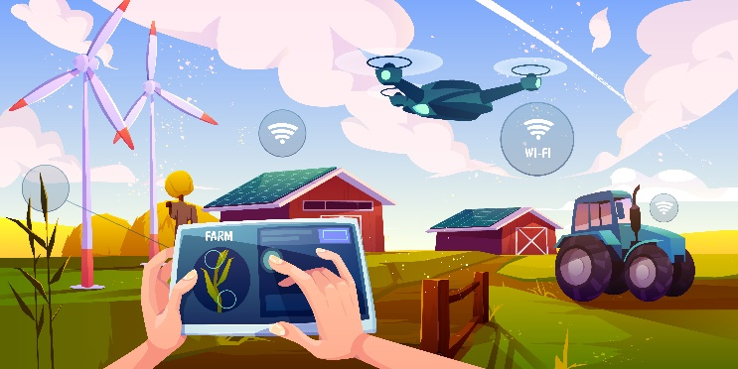

**Fig 6.1.** Futuristic illustration of a farm using AI, IoT, drones, sensors, and automation for efficient farming operations

As the agricultural landscape continues to evolve, integrating AI with domain-specific knowledge and emerging technologies will be crucial for building more intelligent and adaptive farming systems. Future iterations of the Smart Agriculture System will benefit from incorporating geospatial analysis, satellite imagery, and localized weather forecasts to enhance the contextual accuracy of predictions and recommendations. Furthermore, collaborative data sharing among farmers, research institutions, and government bodies can enrich the training datasets, leading to more inclusive and region-specific solutions. These advancements will not only improve the system's performance but also ensure that it remains scalable, resilient, and inclusive for farmers across varying socio-economic and environmental contexts.



**Fig 6.2**. A humanoid AI robot operating in agricultural environment, demonstrating AI-driven automation in farming.

**6.1 Advanced Crop Yield Prediction Models**

As crop yield prediction is one of the primary functions of the Smart Agriculture System, further enhancement in predictive models is crucial for achieving more accurate and reliable results. The current implementation of Long Short-Term Memory (LSTM) networks for crop yield prediction has shown promising results, especially in modeling time-series data such as weather patterns, soil conditions, and crop growth stages. However, there is significant room for improving the model’s accuracy and performance through advanced techniques.

Incorporating More Variables

The current model primarily uses historical weather data, soil conditions, and crop types as input features. To enhance the predictive capability, more variables can be considered, such as:

* Satellite Imagery: Satellite data can provide a wealth of information, such as vegetation indices and real-time monitoring of crop conditions.
* Soil Moisture Sensors: Real-time data from soil moisture sensors can improve the model’s prediction accuracy, especially during dry spells or unusual weather conditions.
* Farmer Inputs: Incorporating data from farmers themselves, such as observations on crop health, pest infestations, and harvesting practices, can provide valuable context to the model.

Hybrid Models for Better Accuracy

While LSTM is a powerful model for time-series prediction, hybrid models that combine LSTM with other advanced machine learning algorithms can significantly improve performance. For instance:

* LSTM-XGBoost Hybrid: Combining LSTM with XGBoost, an ensemble learning model, can enhance feature importance extraction and decision-making capabilities.
* Ensemble Learning: Using an ensemble of multiple models, including Random Forest and Neural Networks, can help to improve generalization and reduce overfitting.

Real-Time Data Integration

To make crop yield predictions more dynamic, the integration of real-time data could be a game-changer. By leveraging real-time weather forecasts, satellite imagery, and IoT sensor data, the model could continuously update its predictions and offer timely advice to farmers. This would allow for faster response times to changing conditions, such as sudden temperature shifts or rainfall, ensuring farmers make more informed decisions about irrigation, fertilization, and harvest timing.

**6.2 Enhancement of the Multilingual Chatbot**

The multilingual chatbot integrated into the Smart Agriculture System provides farmers with the ability to ask questions and receive assistance in various languages. Currently, the chatbot uses natural language processing (NLP) and language detection algorithms to understand user queries and respond in the same language. However, there is potential for significant enhancements to increase the chatbot's utility and effectiveness for a broader range of users.

Improving Language Coverage

At present, the chatbot supports only a limited set of languages, primarily focusing on widely spoken languages like English, Spanish, and Hindi. To make the system more inclusive, additional regional languages need to be integrated. In countries like India, where many local languages and dialects are spoken, a chatbot that can handle languages like Tamil, Telugu, Marathi, and others can increase accessibility and adoption. To achieve this, the following approaches can be implemented:

* Multi-Lingual Model Fine-Tuning: Continuously fine-tuning multilingual models such as mBERT on domain-specific data (i.e., agriculture-related conversations) can improve the system’s understanding of regional dialects and nuances.
* Crowdsourced Data for Rare Languages: Utilizing crowdsourced datasets from native speakers of less common languages can help the chatbot learn specific terms and local agricultural jargon.

Voice Recognition and Natural Interaction

To make the chatbot more user-friendly, especially for farmers who may not be comfortable with typing, integrating voice recognition and text-to-speech (TTS) technology could allow users to interact with the system via voice commands. For instance, a farmer could ask, “What’s the best fertilizer for paddy in Tamil?” and receive a spoken response in Tamil.

Voice recognition combined with NLP can also provide more context-aware conversations, such as asking follow-up questions or giving contextual advice. This interaction model would make the system more natural and intuitive for users, increasing engagement and usage.

Emotion Recognition for Better Responses

Integrating emotion recognition into the chatbot can significantly enhance its ability to provide context-sensitive and empathetic responses. For example, if a farmer expresses frustration due to crop failure or adverse weather conditions, the chatbot could recognize these emotional cues and respond with more empathy and practical suggestions. This could be particularly beneficial in sensitive contexts where emotional support, in addition to technical advice, is required.

**6.3 Integration of IoT for Real-Time Monitoring**

The integration of Internet of Things (IoT) technology with the Smart Agriculture System is another key area for future development. IoT enables real-time data collection from a variety of sensors deployed in the field, providing actionable insights for farmers. While the system currently relies on static data sources, the future of smart agriculture will see real-time monitoring and data-driven decision-making becoming central to the farming process.

Soil Moisture and Temperature Sensors

IoT-based soil moisture sensors and temperature sensors can be used to monitor the environmental conditions in the fields in real-time. This would enable the system to make more accurate recommendations for irrigation, fertilization, and pest control. For example, when soil moisture levels drop below a certain threshold, the system could automatically recommend irrigation or send an alert to the farmer.

Weather Stations and Drones

The use of weather stations and drones equipped with cameras and sensors can provide real-time data on environmental conditions such as temperature, humidity, wind speed, and rainfall. These sensors could also capture data on crop health, such as detecting pest infestations, diseases, or nutrient deficiencies. Integrating these real-time data feeds into the existing system would allow the Smart Agriculture System to continuously update its predictions and provide more relevant, on-the-spot advice to farmers.

Automated Irrigation and Fertilization Systems

With IoT sensors feeding data directly into the system, farmers can set up automated irrigation and fertilization systems that adjust water and fertilizer usage based on the data received. For instance, the system could trigger irrigation if the soil moisture is low, and it could adjust the amount of fertilizer based on soil nutrient content.

**6.4 Conclusion**

The Smart Agriculture System represents a significant leap in improving farming practices through AI, machine learning, and NLP technologies. By enhancing crop yield prediction, integrating multilingual chatbots, and adopting IoT for real-time monitoring, the system has the potential to revolutionize agriculture by making it more efficient, sustainable, and accessible to farmers across the globe. However, as we move forward, the continuous refinement of these technologies and their integration into practical, everyday farming operations will be essential. The future holds immense possibilities for enhancing the capabilities of smart agriculture systems, ensuring that they can address the ever-growing demands of the agricultural sector.

**REFERENCES**

[1] Authors: Smith, J. Title: Machine Learning in Agriculture: Trends and Applications Year: 2022

[2] Authors: Brown, A.; Green, M.; et al. Title: Deep Learning for Crop Disease Detection Year: 2021

[3] Authors: Johnson, L. Title: Predictive Analytics for Yield Estimation Year: 2020

[4] Authors: Gupta, R.; Singh, P. Title: NLP-Based Chatbots in Precision Farming Year: 2019

[5] Authors: Patel, V.; et al. Title: Edge Computing in Smart Agriculture Year: 2023

[6] Authors: Zhang, Y.; Chen, X. Title: Random Forest for Crop Recommendation: A Comparative Analysis Year: 2022

[7] Authors: Lee, M.; et al. Title: Enhancing Decision Support Systems with AI Year: 2021

[8] Authors: Kim, H. Title: Blockchain for Agricultural Data Security Year: 2020

[9] Authors: Wu, J.; et al. Title: IoT and Cloud Computing in Farming Year: 2022

[10] Authors: Davis, R. Title: Reinforcement Learning for Adaptive Agriculture Year: 2019

[11] Authors: Thomas, K. Title: Sustainable Farming through AI Year: 2023

[12] Authors: Tatsunami, Y.; Taki, M. Title: Sequencer: Deep LSTM for Image Classification Year: 2022

[13] Authors: Boström, H. Title: Example-Based Explanations of Random Forest Predictions Year: 2023

[14] Authors: Vipoooool Title: New Plant Diseases Dataset (Kaggle Dataset) Year: 2022

[15] Authors: Aakash N. Title: ResNet Tutorial (Jovian.ai) Year: 2021

[16] Authors: Unknown Title: International Journal of Computer Applications in Technology, Vol. 14, Issue 2 Year: (approx.) 2020

**APPENDIX**

1. **CODING**

The entire backend of the AI-powered sustainable agriculture system is developed using **Flask**, a lightweight Python web framework. The application utilizes **Flask Blueprints** to modularize different components such as:

* crop_module.py – handles crop and fertilizer recommendations using Random Forest.
* disease_module.py – handles image-based disease detection using ResNet9.
* yield_module.py – contains logic for yield forecasting using LSTM.
* chatbot_module.py – interfaces with mBERT and TF-IDF for multilingual NLP responses.

The Blueprints structure ensures maintainability, separation of concerns, and scalable integration between AI modules. APIs are exposed for mobile or web frontends to interact with AI services.

App.py

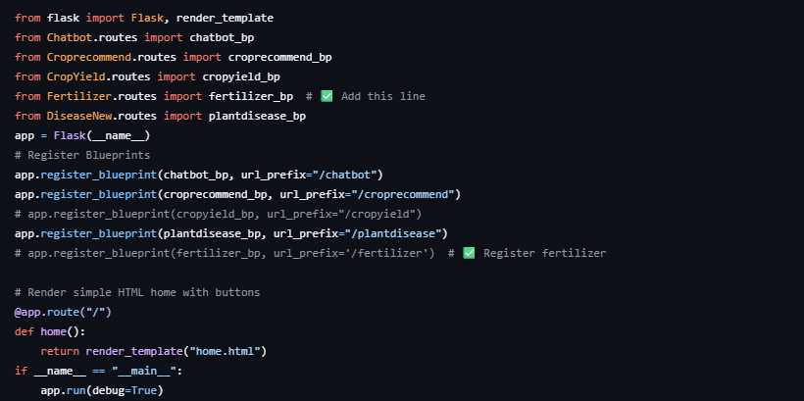

Plant Disease

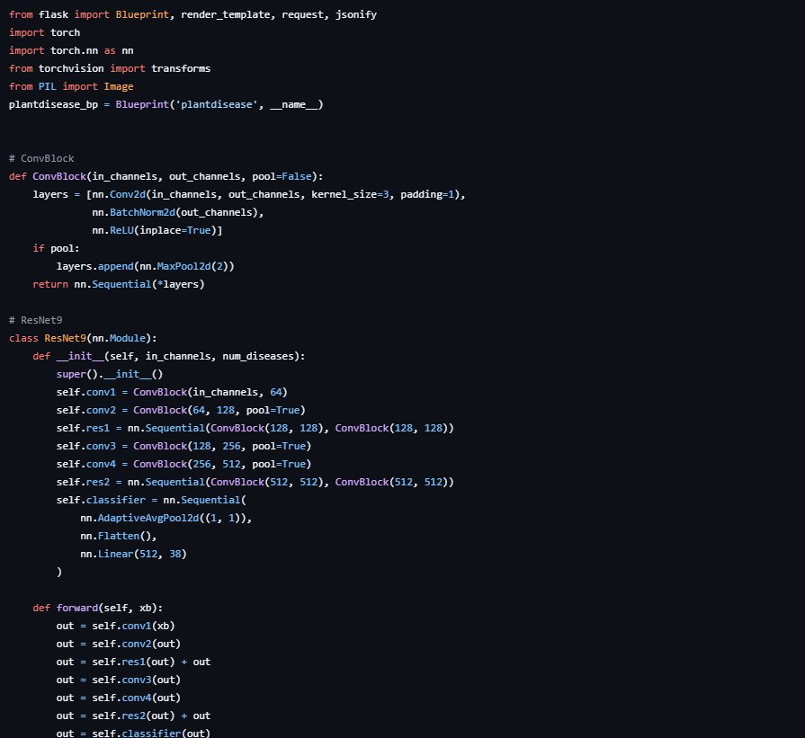

Crop Recommend

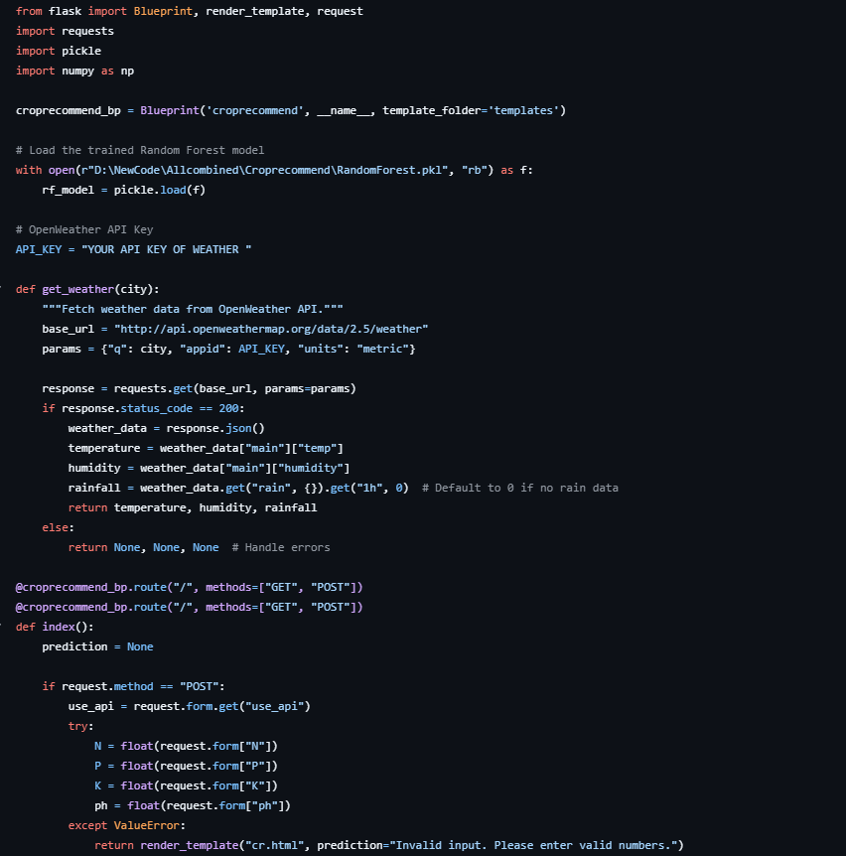

Crop Yield

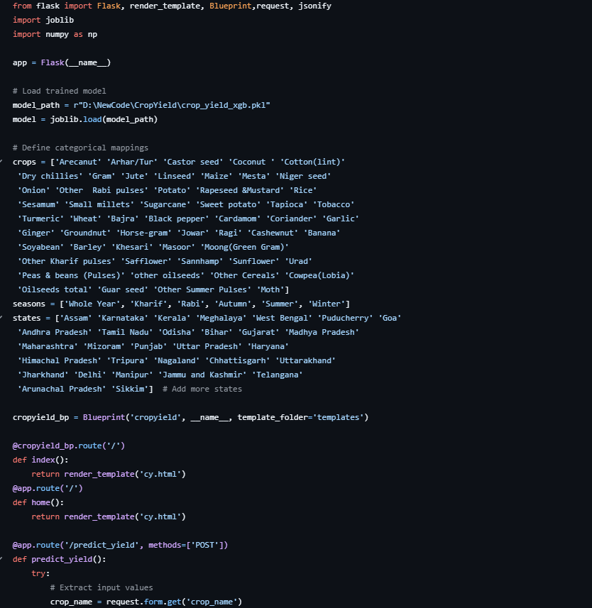

Chatbot

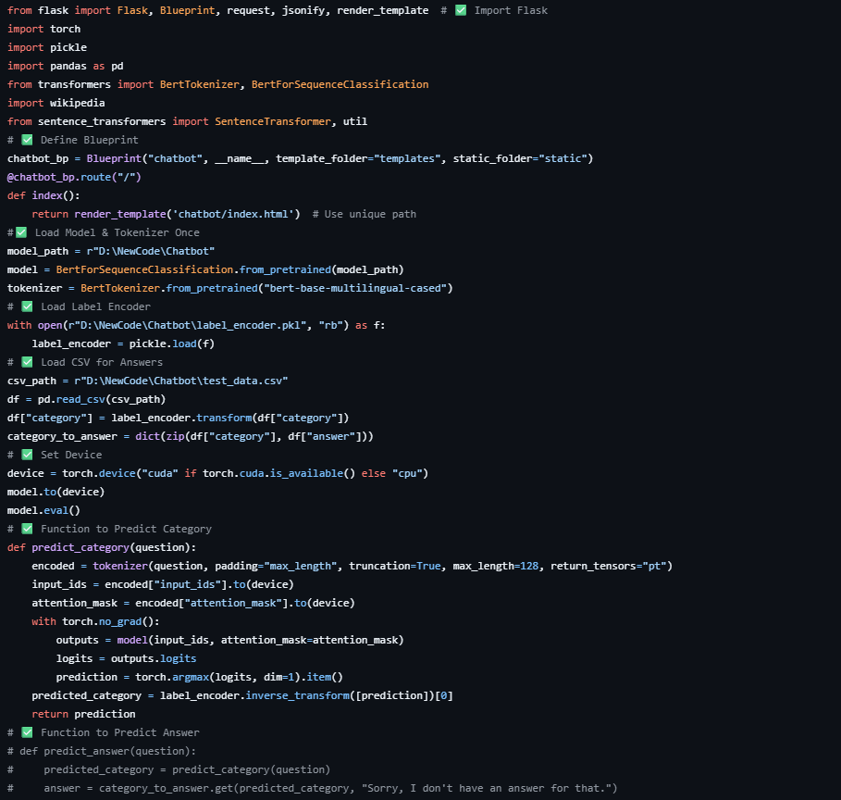

Plant Disease model

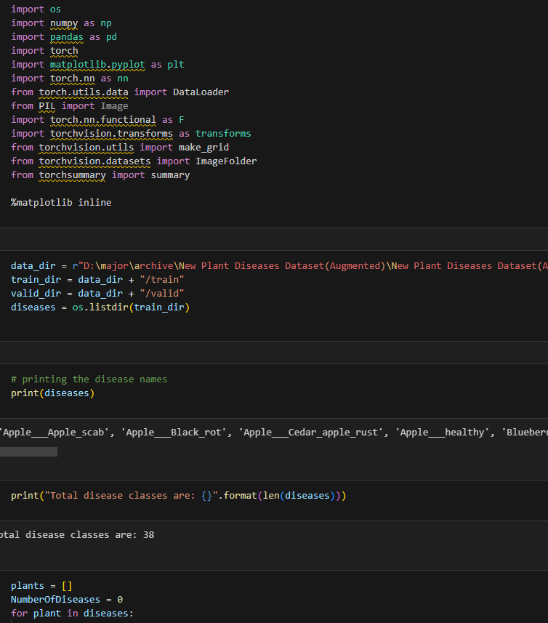

**B. CONFERENCE PUBLICATION**

* **Conference Name**: *2025 2nd International Conference on Data Science and Business Systems (ICDSBS 2025)*
* **Paper Title**: *AI-Powered Sustainable Agriculture*
* **Paper ID**: *1444*
* **Status**: Accepted and Presented
* **Date**: 17 April 2025
* The paper has been peer-reviewed and accepted for presentation at one of the leading conferences focusing on AI applications in business and data systems, affirming its relevance and innovation.



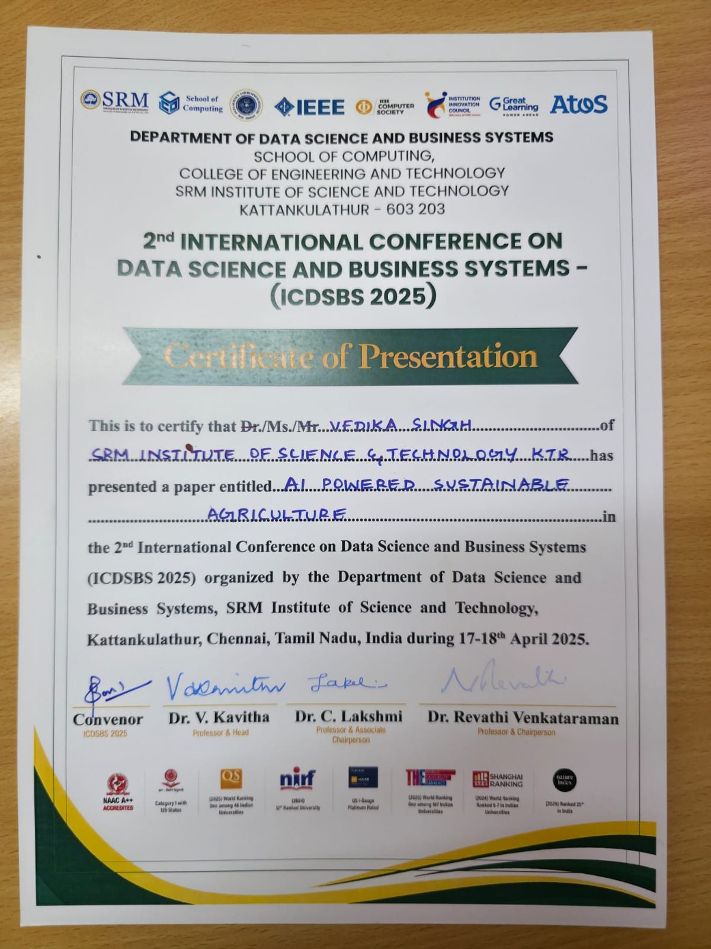

**C. JOURNAL PUBLICATION**

*We have submitted our research paper titled “AI-Powered Sustainable Agriculture” for journal publication following its acceptance and presentation at 2025 2nd International Conference on Data Science and Business Systems (ICDSBS 2025) held at SRM Institute of Science and Technology.*

*The manuscript is currently under review with the journal associated with the conference, and we have confirmation of its acceptance and presented there for the upcoming issue. We anticipate receiving a formal update from the editorial committee soon.*

*Research Paper Attached Below*





















**PLAGIARISM REPORT**

|  |  |  |
| --- | --- | --- |
| **SRM INSTITUTE OF SCIENCE AND TECHNOLOGY**  **(Deemed to be University u/s 3 of UGC Act, 1956)** | | |
| **Office of Controller of Examinations** | | |
| REPORT FOR PLAGIARISM CHECK ON THE SYNOPSIS/THESIS/DISSERTATION/PROJECT REPORTS | | |
| 1 | Name of the Candidate  **(IN BLOCK LETTERS)** | JAYESH POONIA  VEDIKA SINGH |
| 2 | Address of the Candidate | Hanwant sigh so tulsaram poonia  Street no 7 gandhi nagar  Barmer,Rajasthan  D/3305 oberoi Sky City, Dattapada road, Borivali East Mumbai |
| 3 | Registration Number | RA2111030010261  RA211103010295 |
| 4 | Date of Birth | 26-09-2002  23-01-2004 |
| 5 | Department | NWC |
| 6 | Faculty | Engineering and Technology |
| 7 | Title of the Synopsis/ Thesis/ Dissertation/Project | AI-Powered Sustainable Agriculture |
| 8 | Name and address of the Supervisor / Guide | Dr.D.Saisanthiya,  Assistant Professor,  Department of Networking and Communications,  School of Computing,  Faculty of Engineering and Technology,  SRM Institute of Science and Technology,  Kattankulathur.  **Mail ID** : saisantd@srmist.edu.in  **Mobile Number** :9786454422 |
| 9 | Name and address of the Co-Supervisor  / Co- Guide (if any) | NA  **Mail ID :**  **Mobile Number** : |
| 10 | Software Used |  |
| 11 | Date of Verfication |  |

|  |  |  |  |  |
| --- | --- | --- | --- | --- |
| 12 | **Plagiarism Details: (to attach the final report)** | | | |
| **Chapter** | **Title of the Chapter** | **Percentage of similarity index (including self citation)** | **Percentage of similarity index (Excluding self citation)** | **% of plagarism after excluding Quotes, Bibliography, etc.,** |
| **1** |  |  |  |  |
| **2** |  |  |  |  |
| **3** |  |  |  |  |
| **4** |  |  |  |  |
| **5** |  |  |  |  |
| **6** |  |  |  |  |
| **7** |  |  |  |  |
| **8** |  |  |  |  |
| **9** |  |  |  |  |
| **10** |  |  |  |  |
| **Thesis abstract** | |  |  |  |
| **Appendices** | |  |  |  |
| I / We declare that the above information have been verified and found true to the best of my / our knowledge. | | | | |
| **Signature of the Candidate** | | **Signature of the Supervisor / Guide** | | |
| **Signature of the Co-Supervisor/Co-Guide** | | **Signature of the HOD / DRCC Chairperson** | | |
| **Signature of the Librarian** | | | | |